Step: 01

To create a resource group in Azure Portal, first navigate to Resource Groups and click the Create button. You will need to provide your subscription details, assign a name for the resource group, and select your preferred region. Once you have entered all the required information, click Review + Create to proceed.

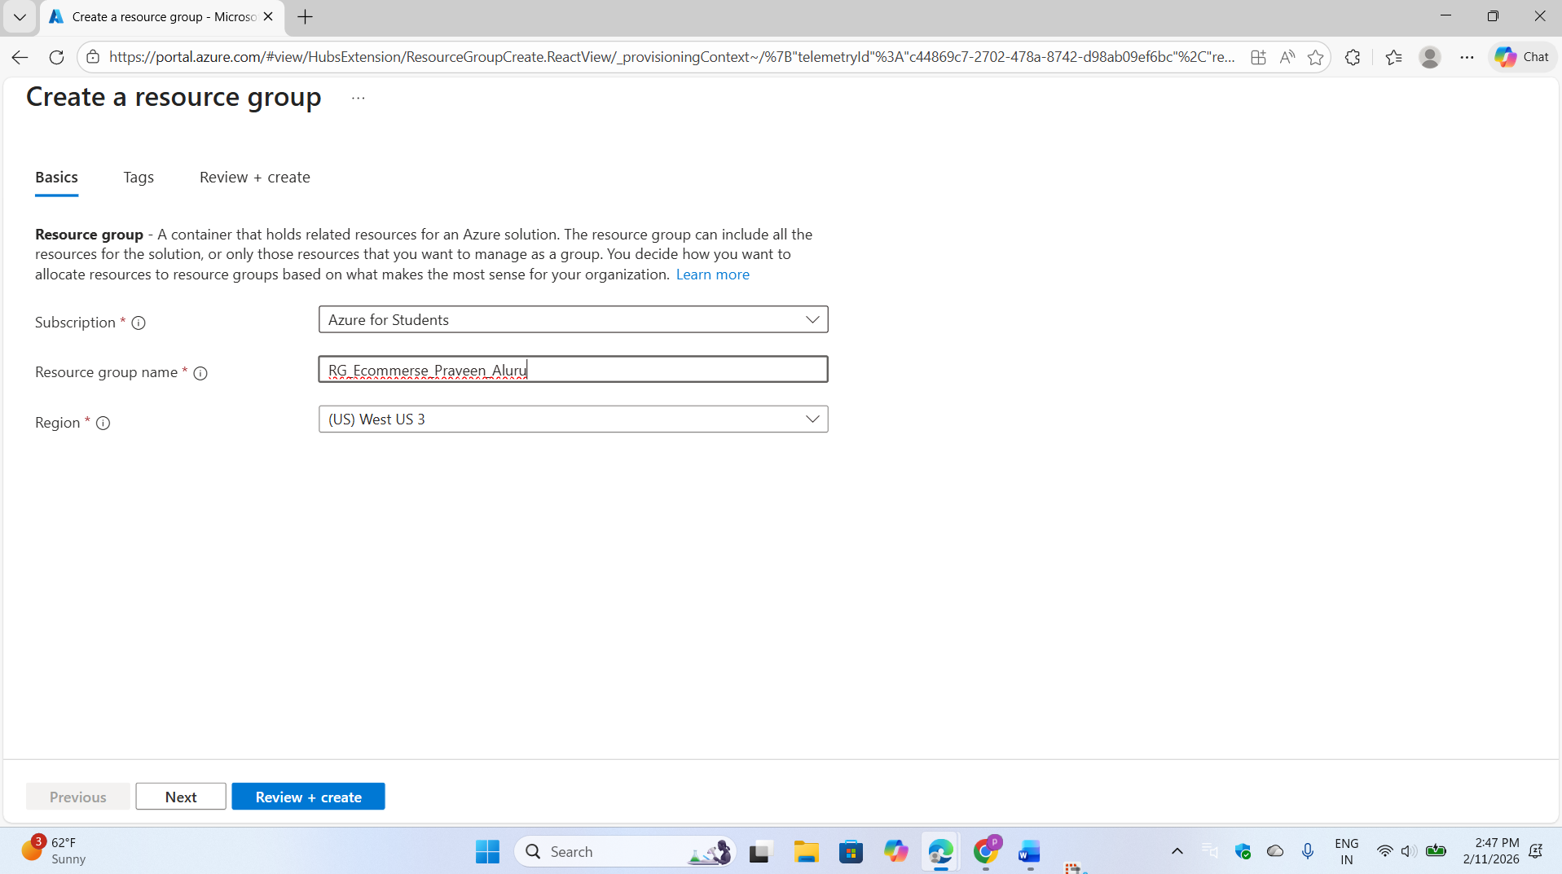

After the system completes its validation successfully, finalize the process by clicking the Create button.

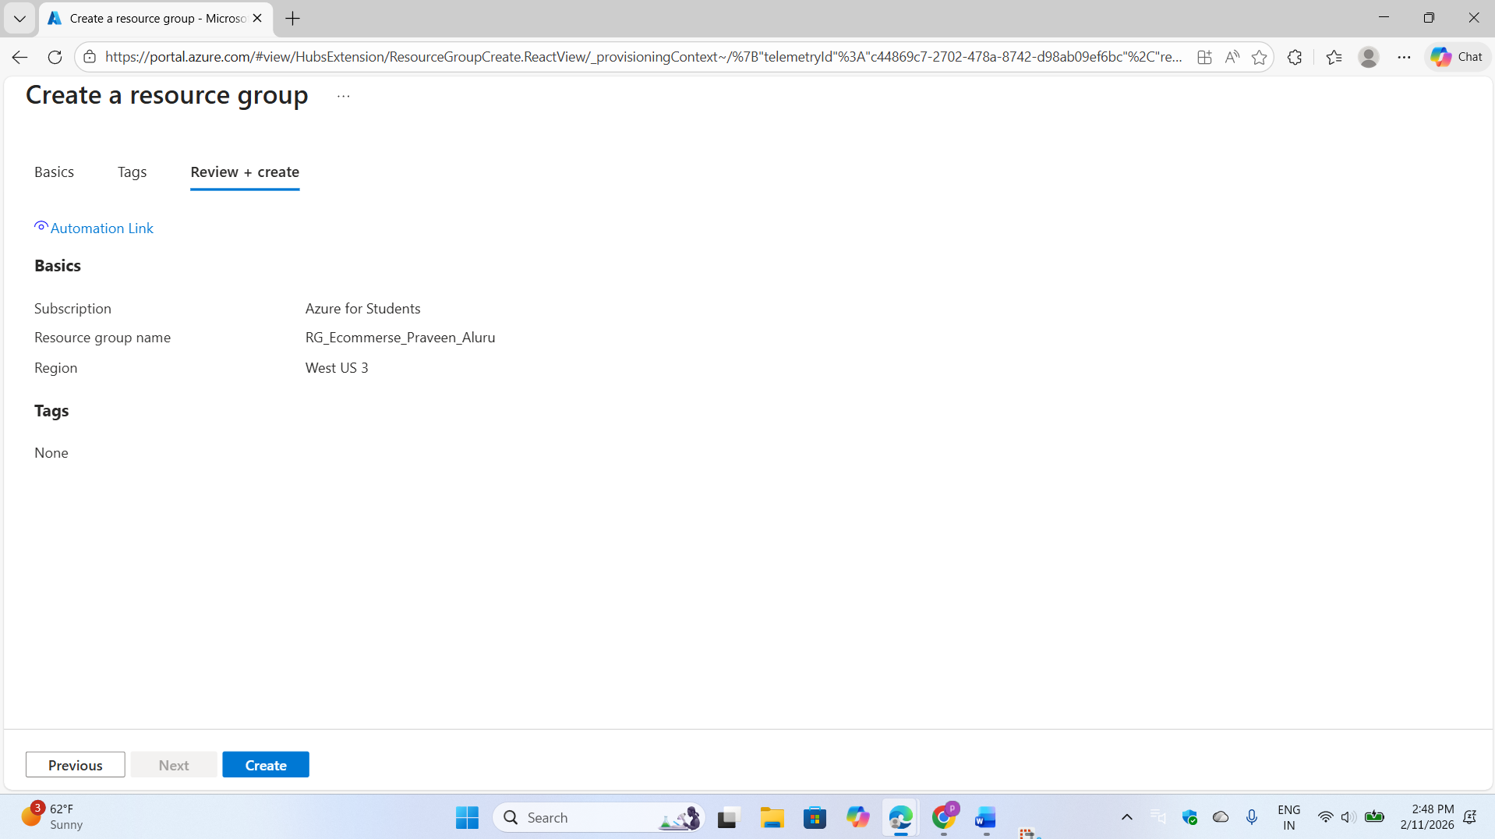

**Purpose:**

A Resource Group logically organizes all Azure resources (Storage Account, ADLS, etc.) related to this project.

Step:02

To create a storage account, click "Create Storage Account" and provide the storage account name, region, and performance settings. Ensure you enable Hierarchical Namespace (required for ADLS Gen2),

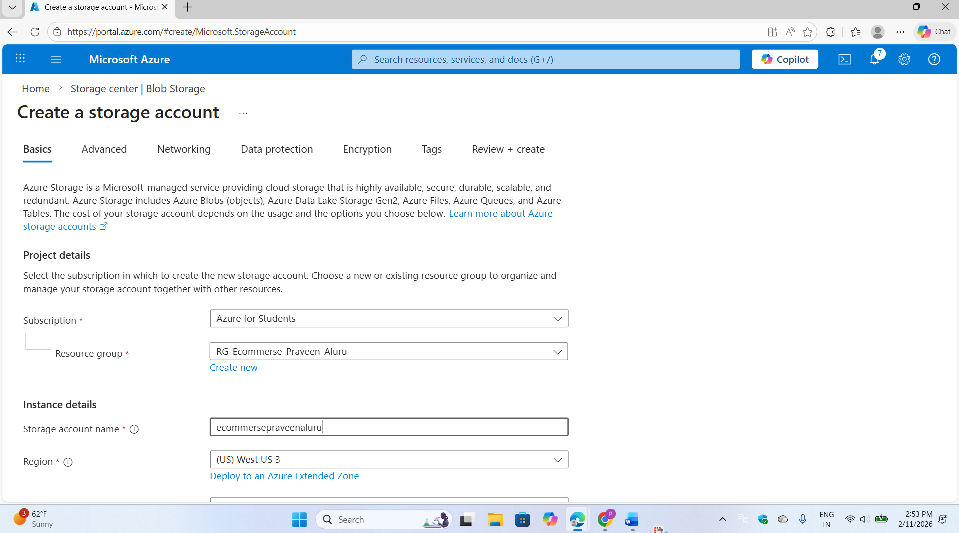

then click "Review + Create." After validation completes, click "Create" to finalize the setup.

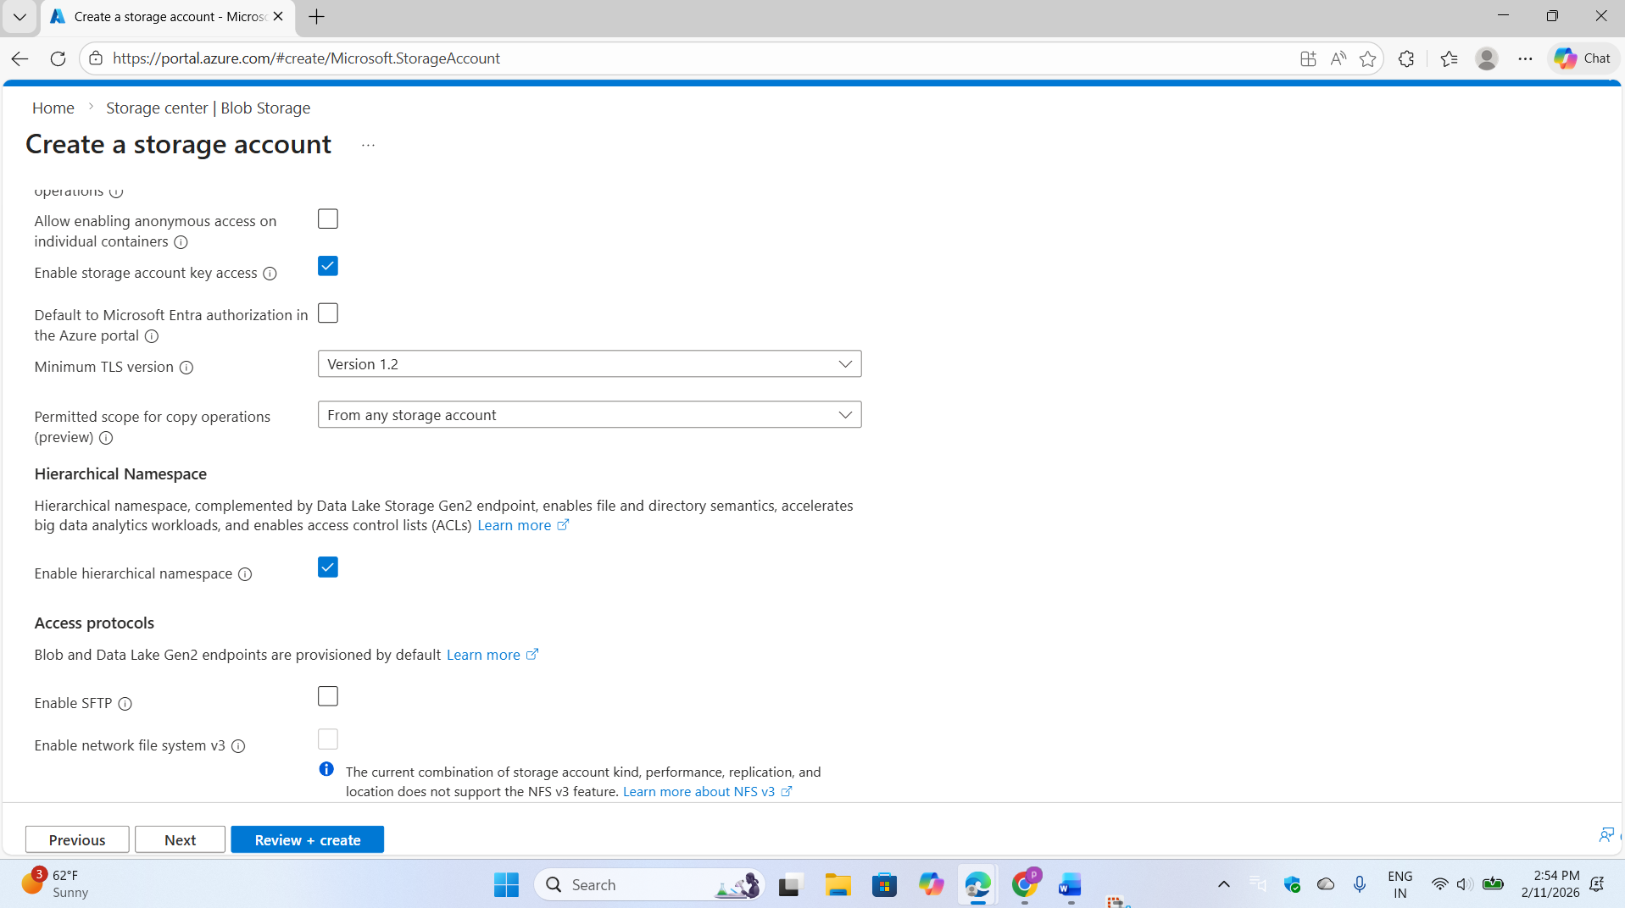

**Purpose:**

ADLS Gen2 allows us to store raw e-commerce data efficiently with big data analytics compatibility.

Now we can see successfully created azure data lake storage for ecommerce raw data

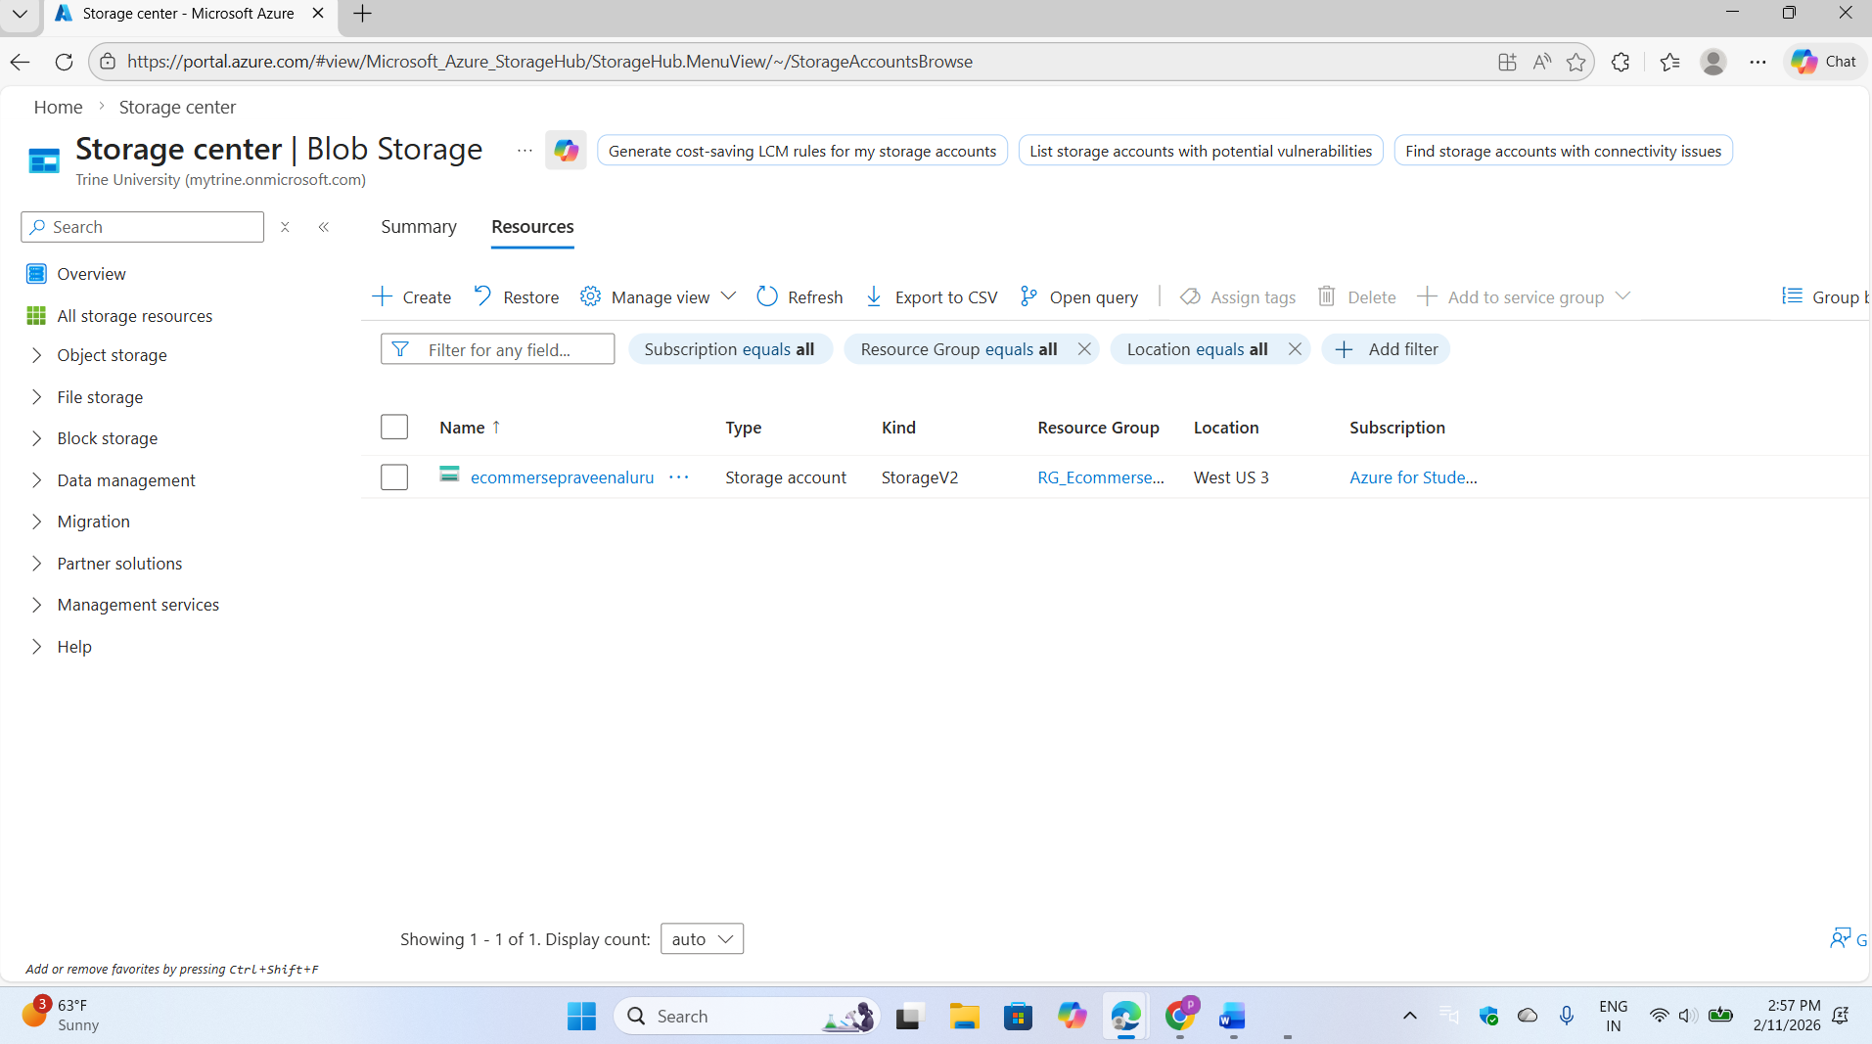

Create a container in Azure Data Lake Storage (ADLS) with a subfolder designated for raw e-commerce data

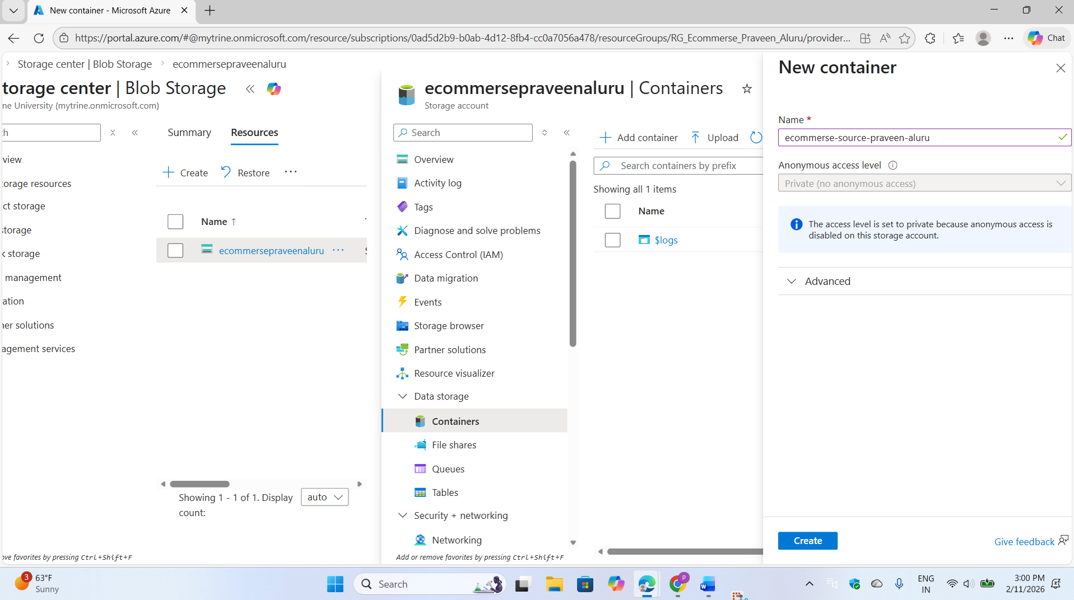

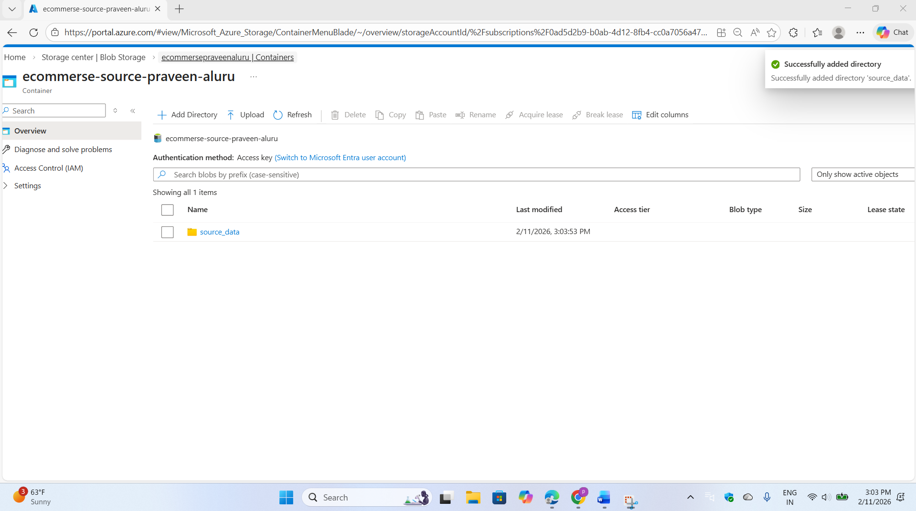

then manually upload CSV files from your local machine to this location.

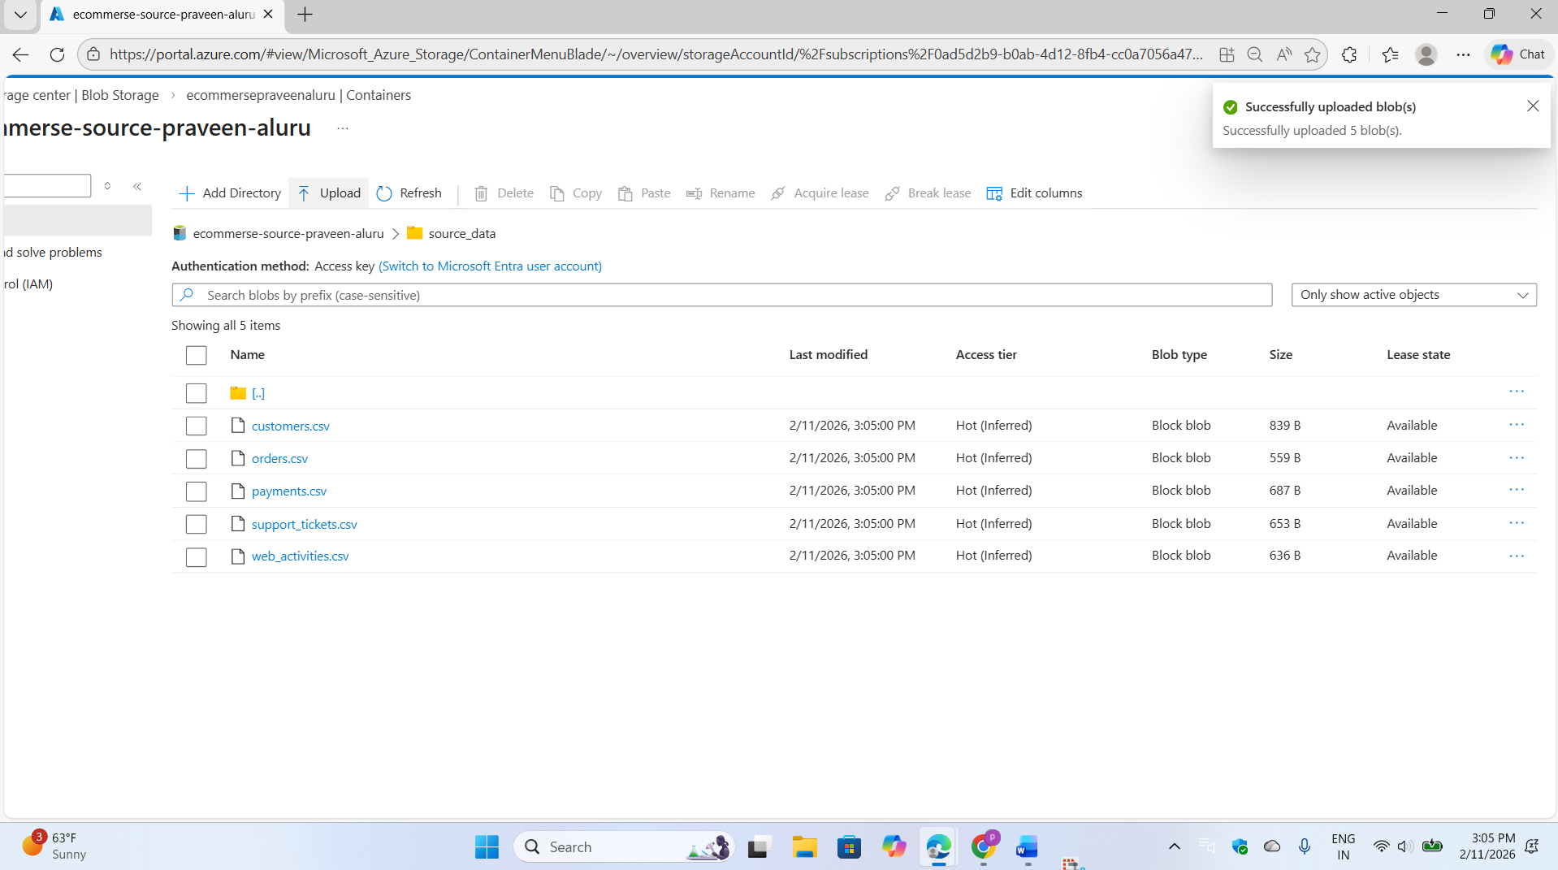

**Purpose:**

This acts as the **Raw Data Landing Zone** for the project.

Step:03

Let's log in into Microsoft Fabric and explore its interface.

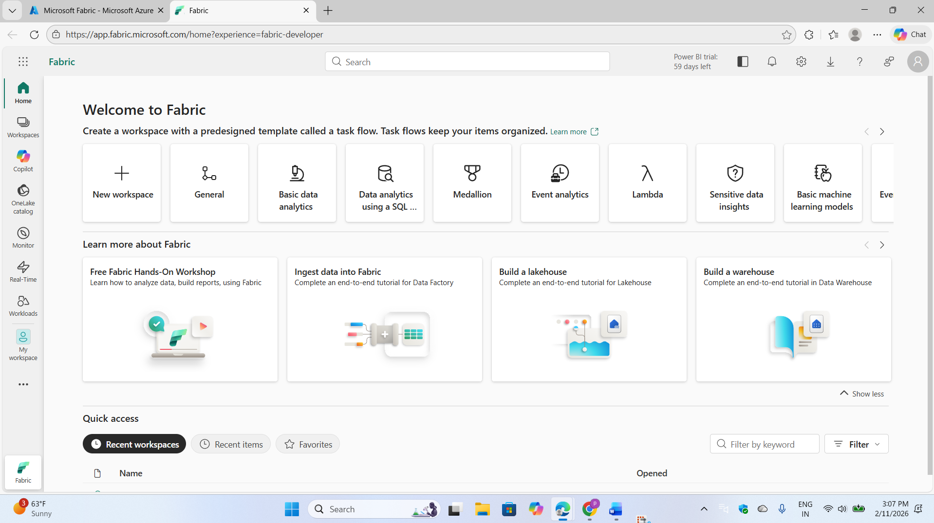

To begin the E-Commerce Analytics Project, log in to Microsoft Fabric and create a new workspace specifically designated for this initiative, ensuring to name it appropriately to reflect the E-Commerce Analytics Project purpose.

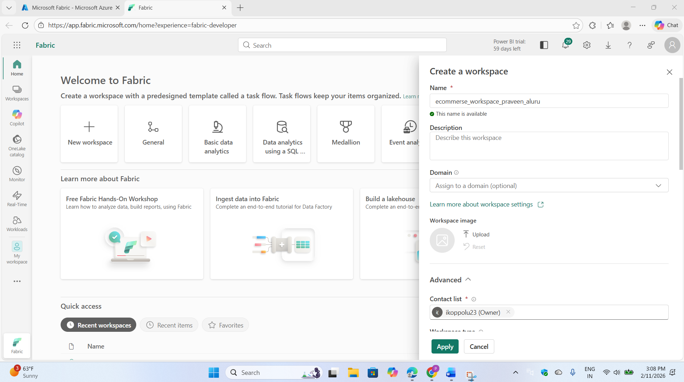

Design and implement a data migration pipeline that transfers raw e-commerce data from Azure Data Lake Storage (ADLS) to a Lakehouse architecture.

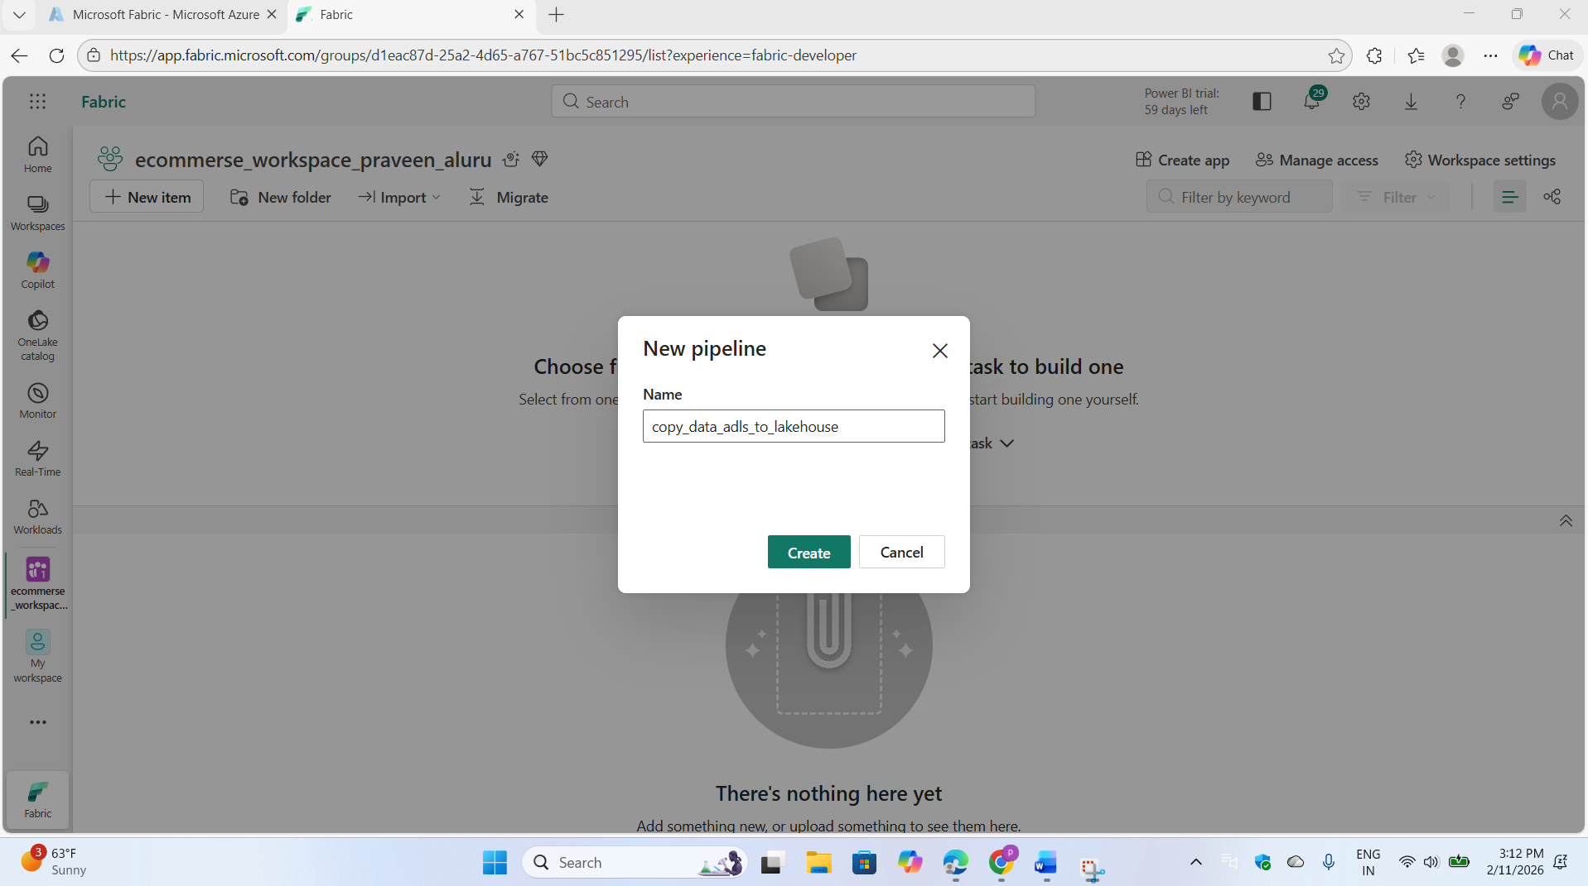

The Get Metadata activity enables retrieval of all files from a specified folder by providing the endpoint URL and account key to access data from Azure Data Lake Storage (ADLS)

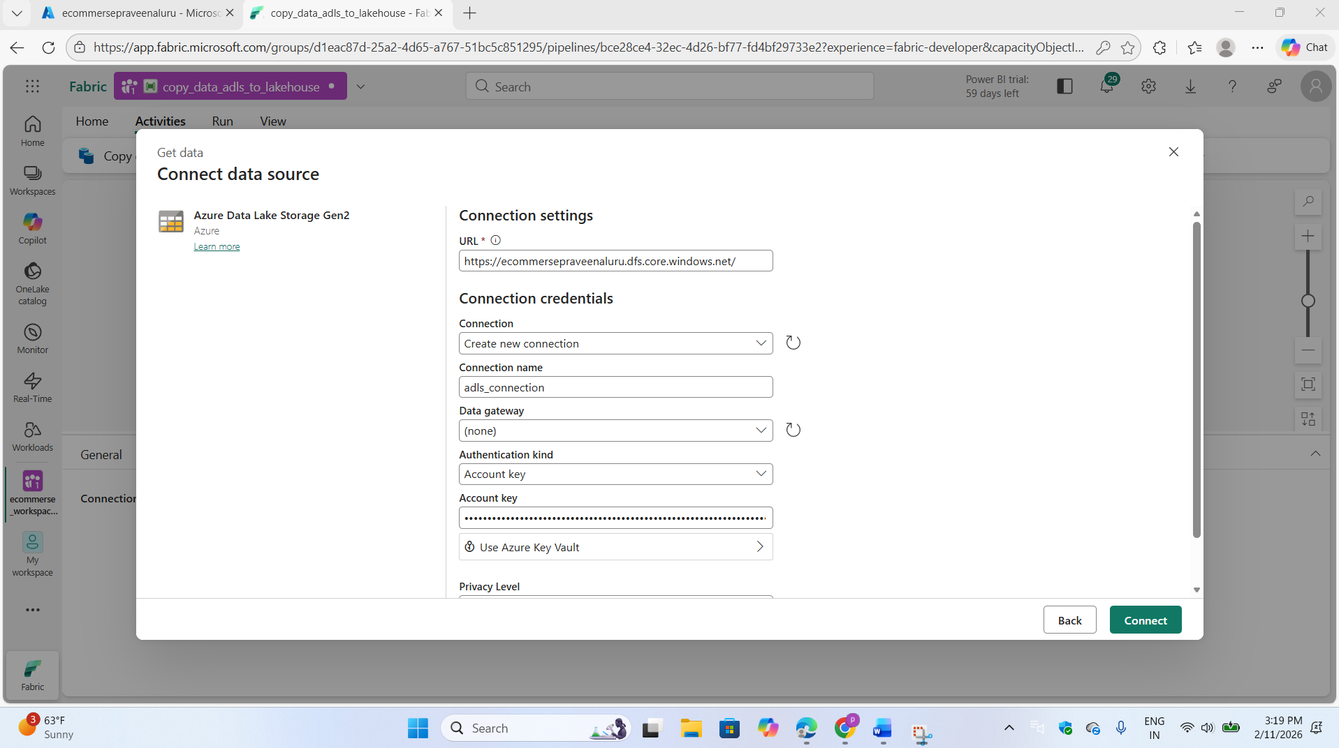

**Purpose:**

Workspace acts as a development environment for:

1.Pipelines 2.Lakehouse 3.Notebooks 4.Semantic Models and 4.Reports

After assigning and successfully testing the connection, we ran the pipeline. The Get Metadata activity then reads all files from the folder.

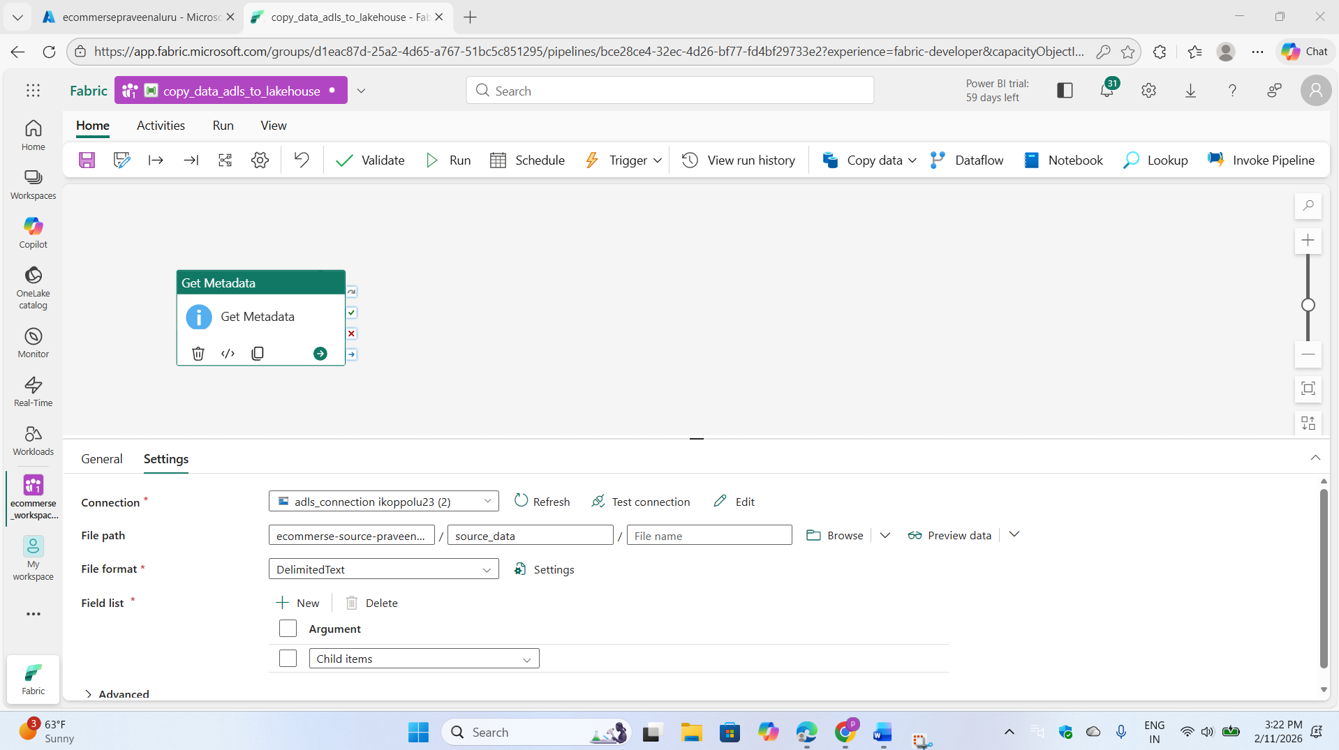

Successfully executed the get metadata activity.

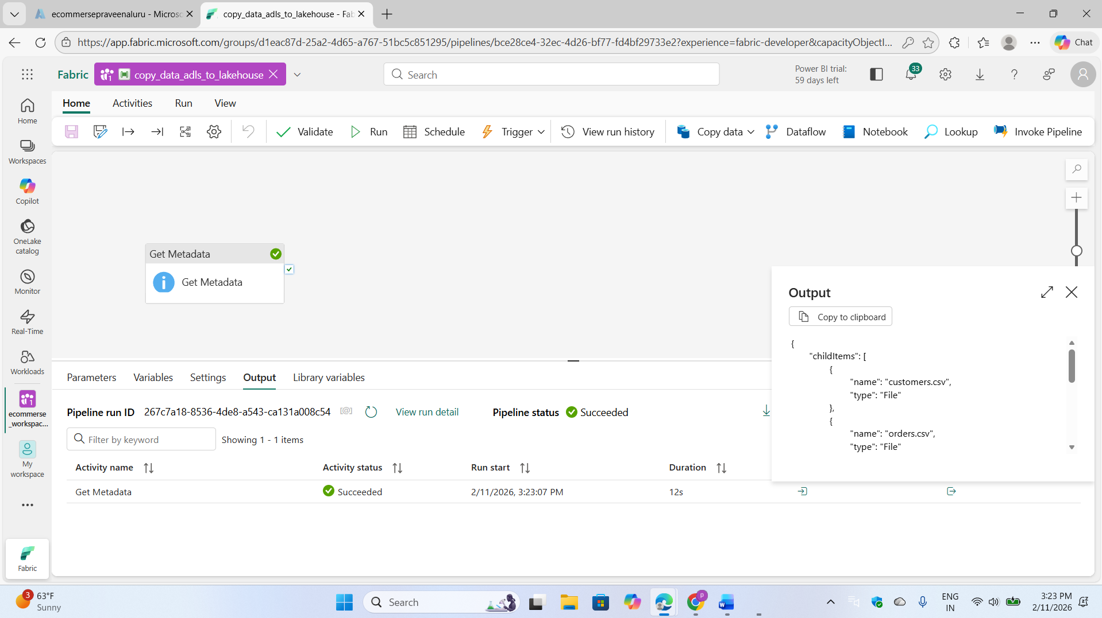

Use a ForEach activity to iterate through files from the Get Metadata activity output. Within the loop, use a Copy activity to transfer each file to the lakehouse bronze folder.

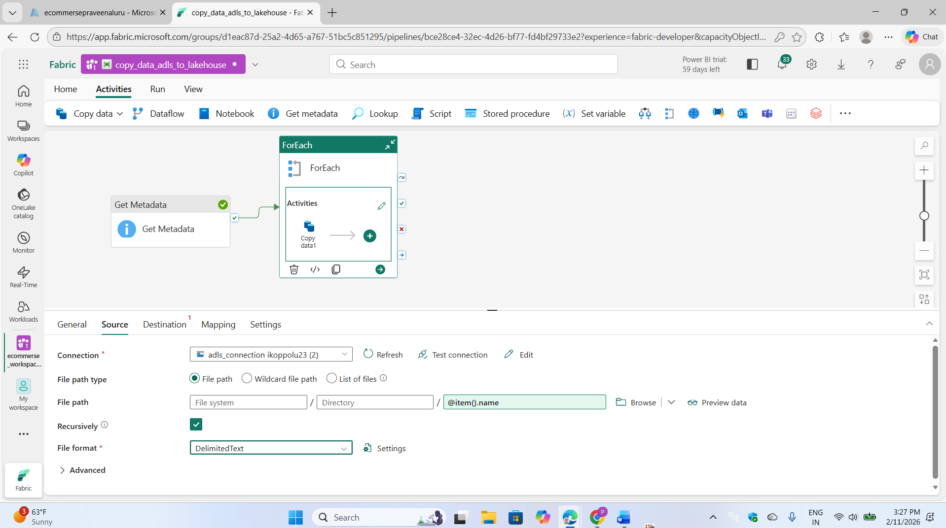

We implemented a medallion architecture pattern, storing raw data in the bronze layer.

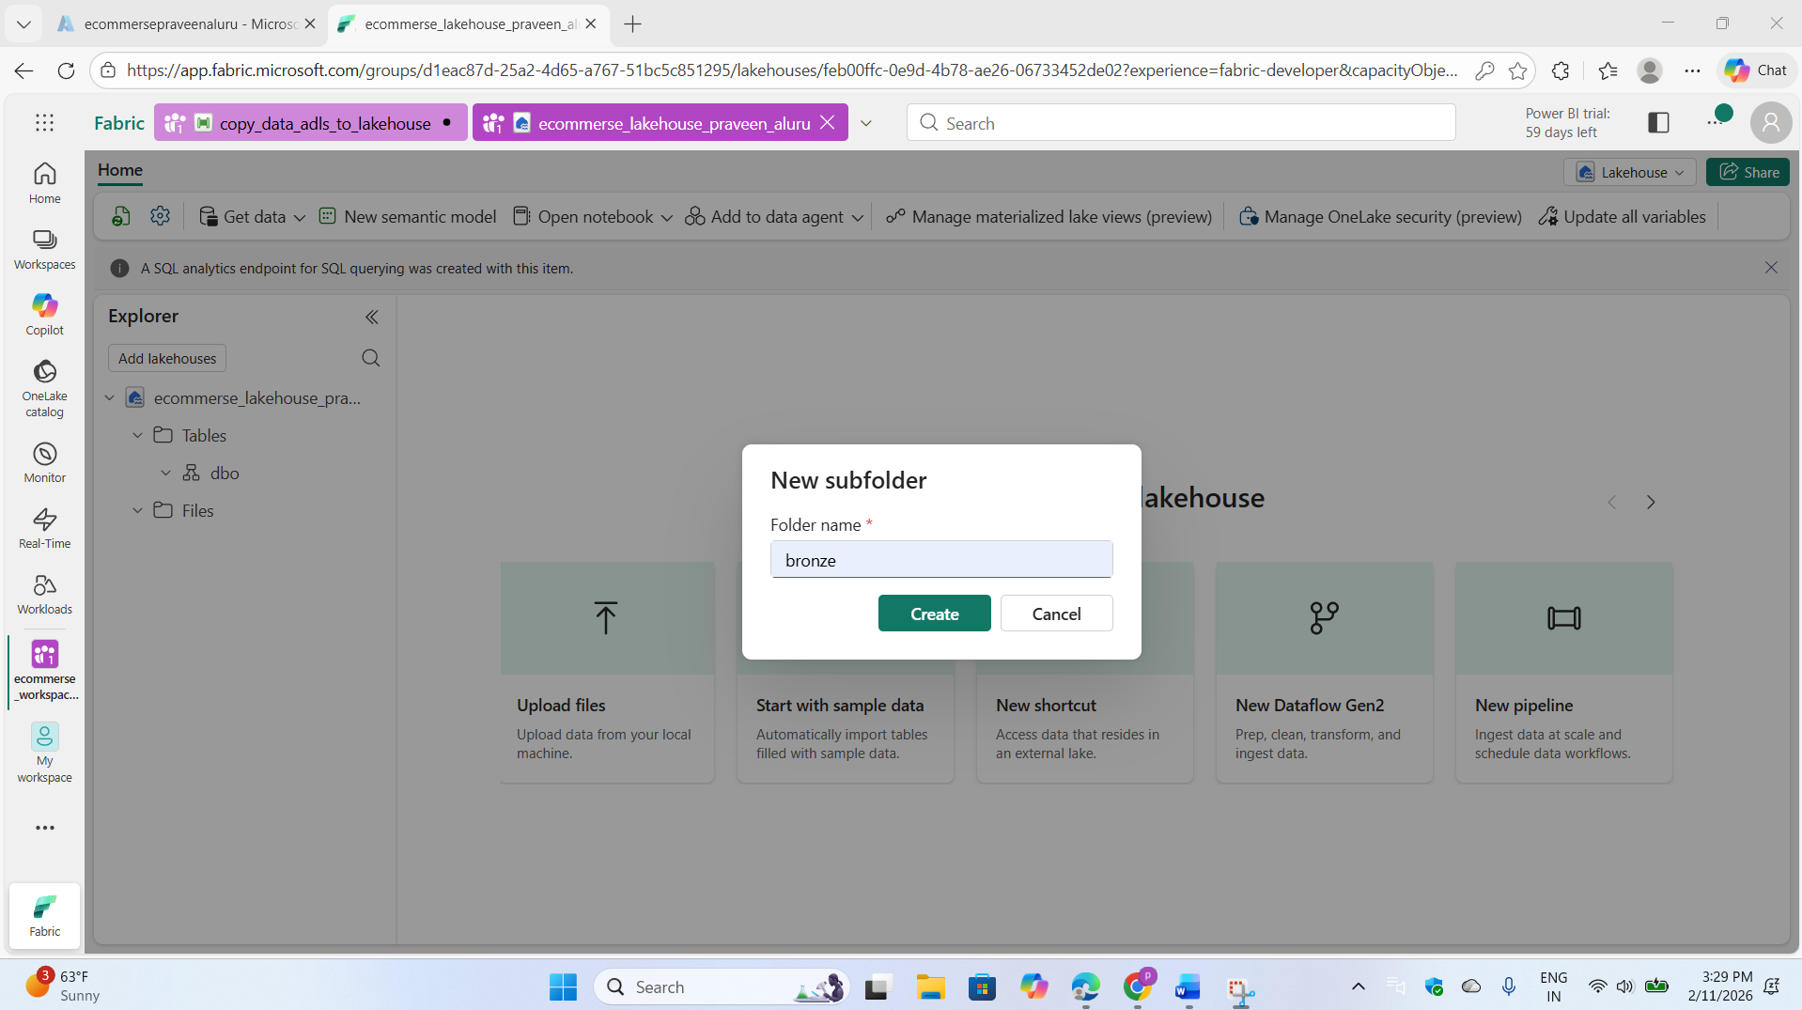

We executed the pipeline, and you can observe the file-copying process for each activity. As shown here, some files have been successfully copied while others are currently in progress.

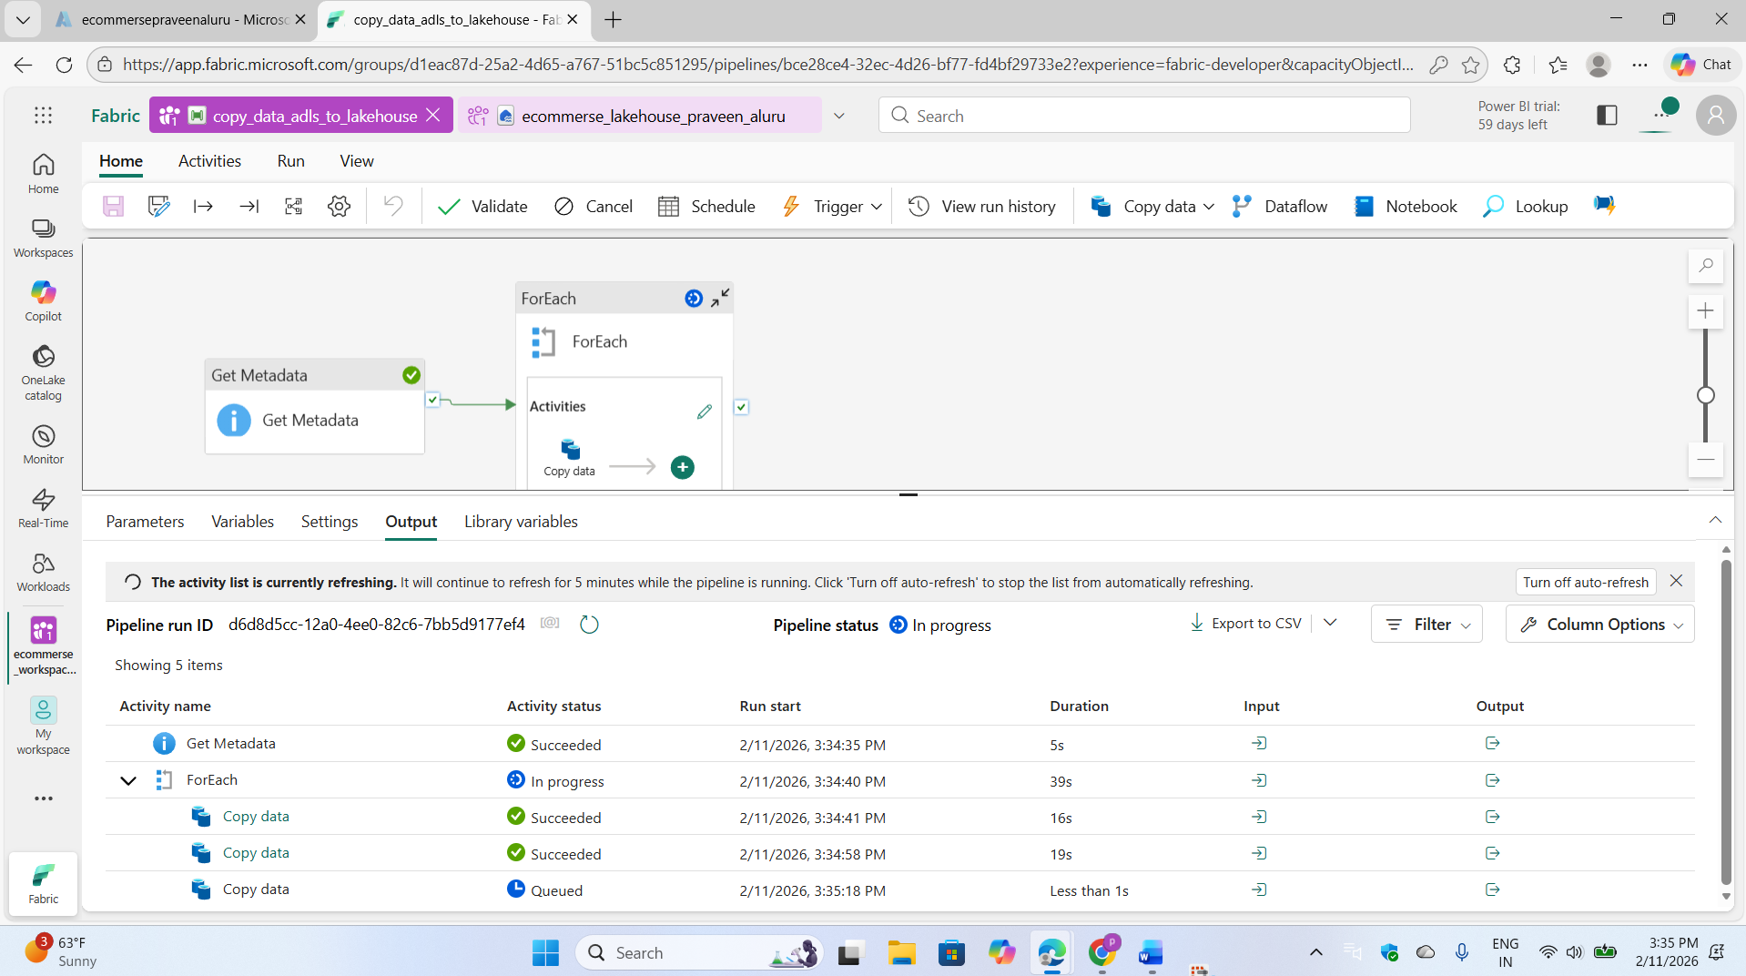

We can see here all the files successfully copied into Lakehouse bronze layer

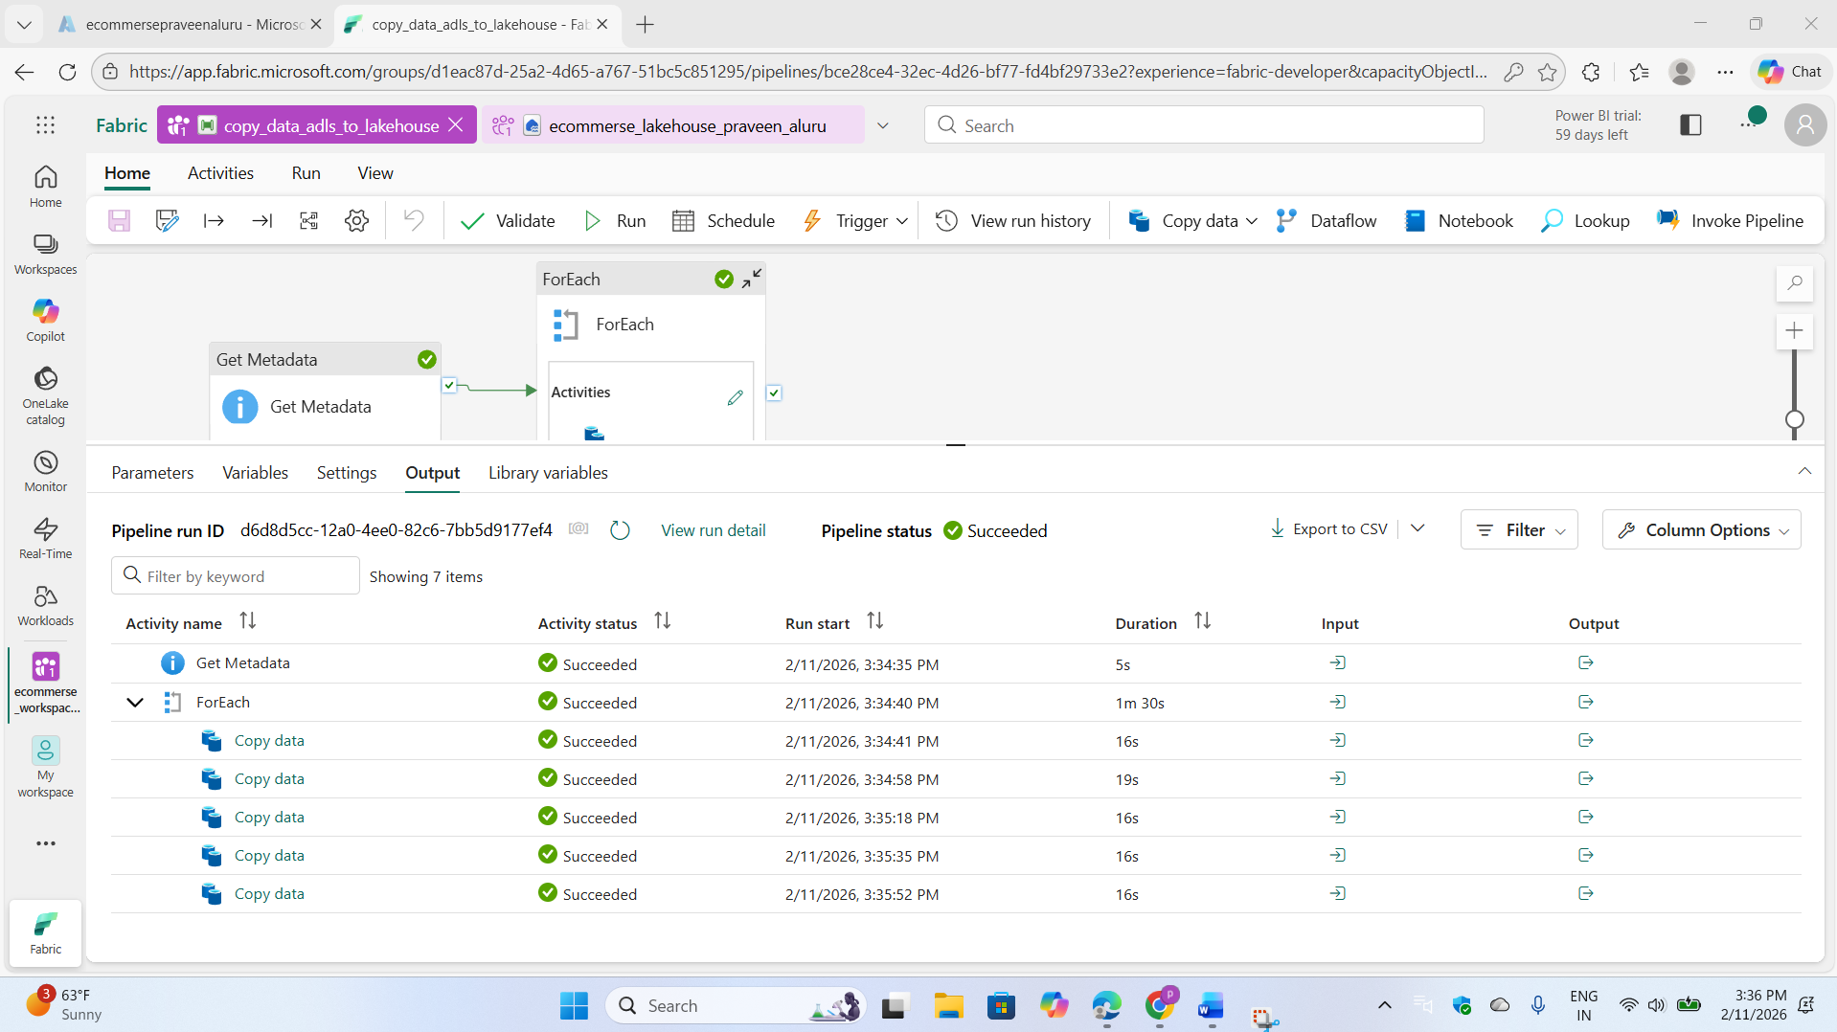

Now we can see all the files available in bronze layer

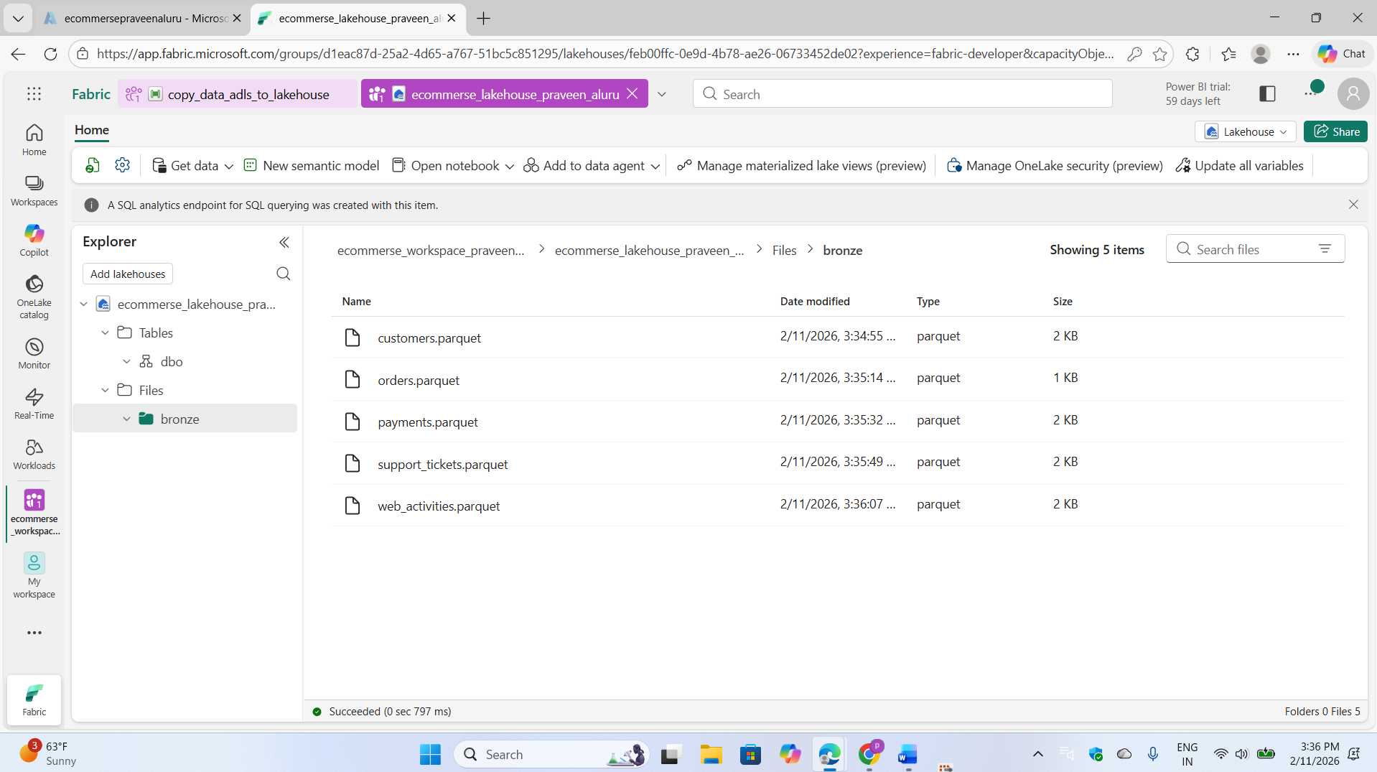

Step: 04

We created a notebook for data transformation and connected it to the lakehouse to retrieve raw data.

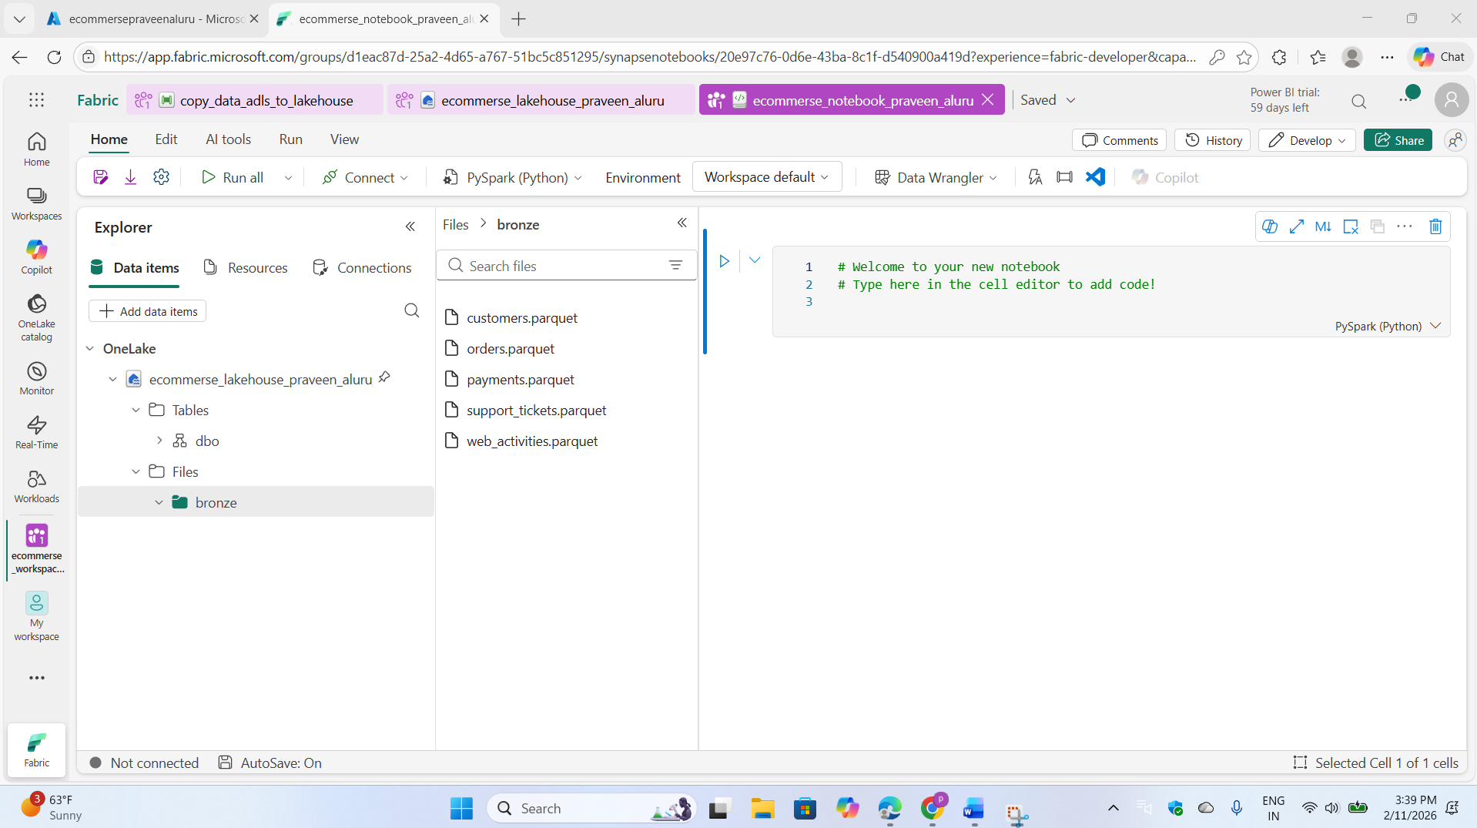

I developed a data processing notebook connected to a Lakehouse that ingested data from five source tables (Customers, Orders, Payments, Support, and Web Activity) using ABFSS paths into DataFrames. After performing data quality operations including null removal, data type corrections, and transformations using PySpark functions, I wrote the cleaned datasets as managed Delta tables to the Silver Layer for downstream analytics.

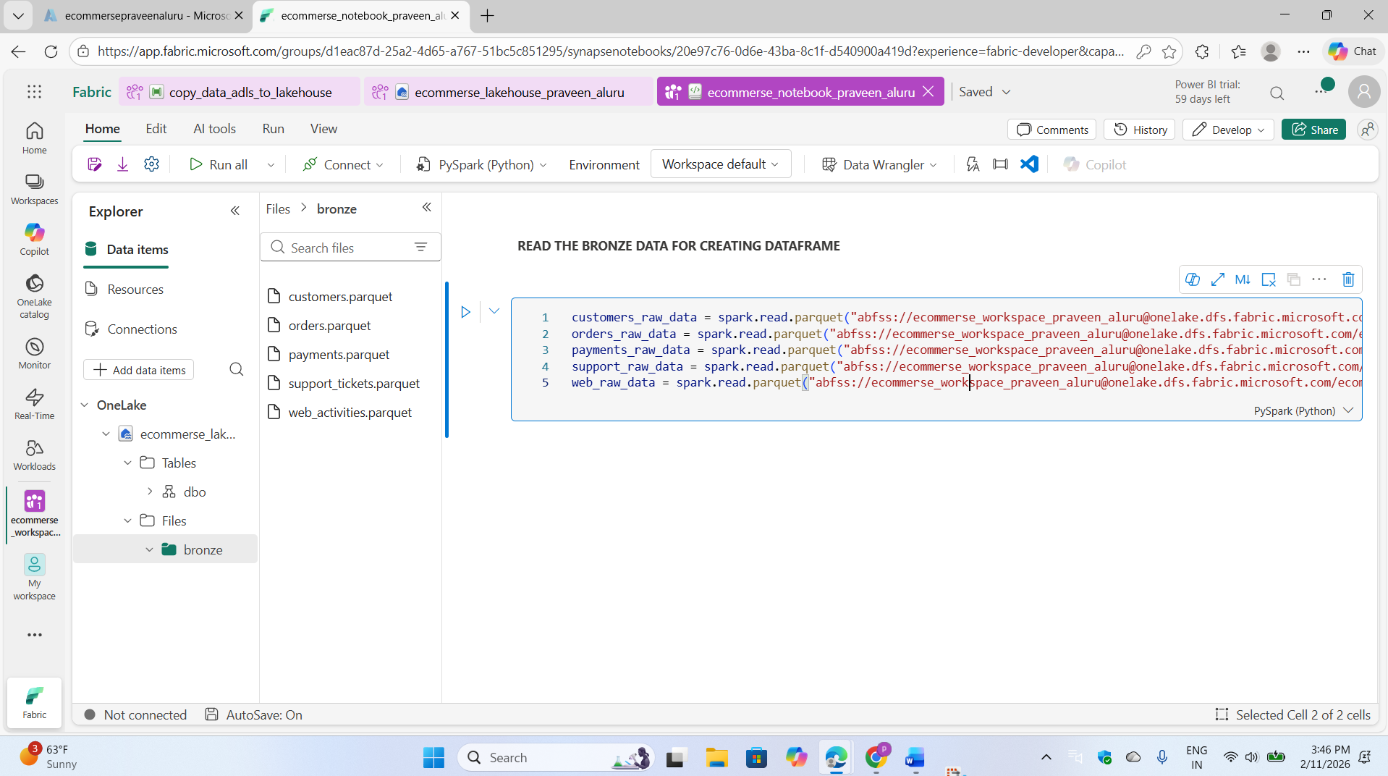

Let's now display the top 5 records from the customer file

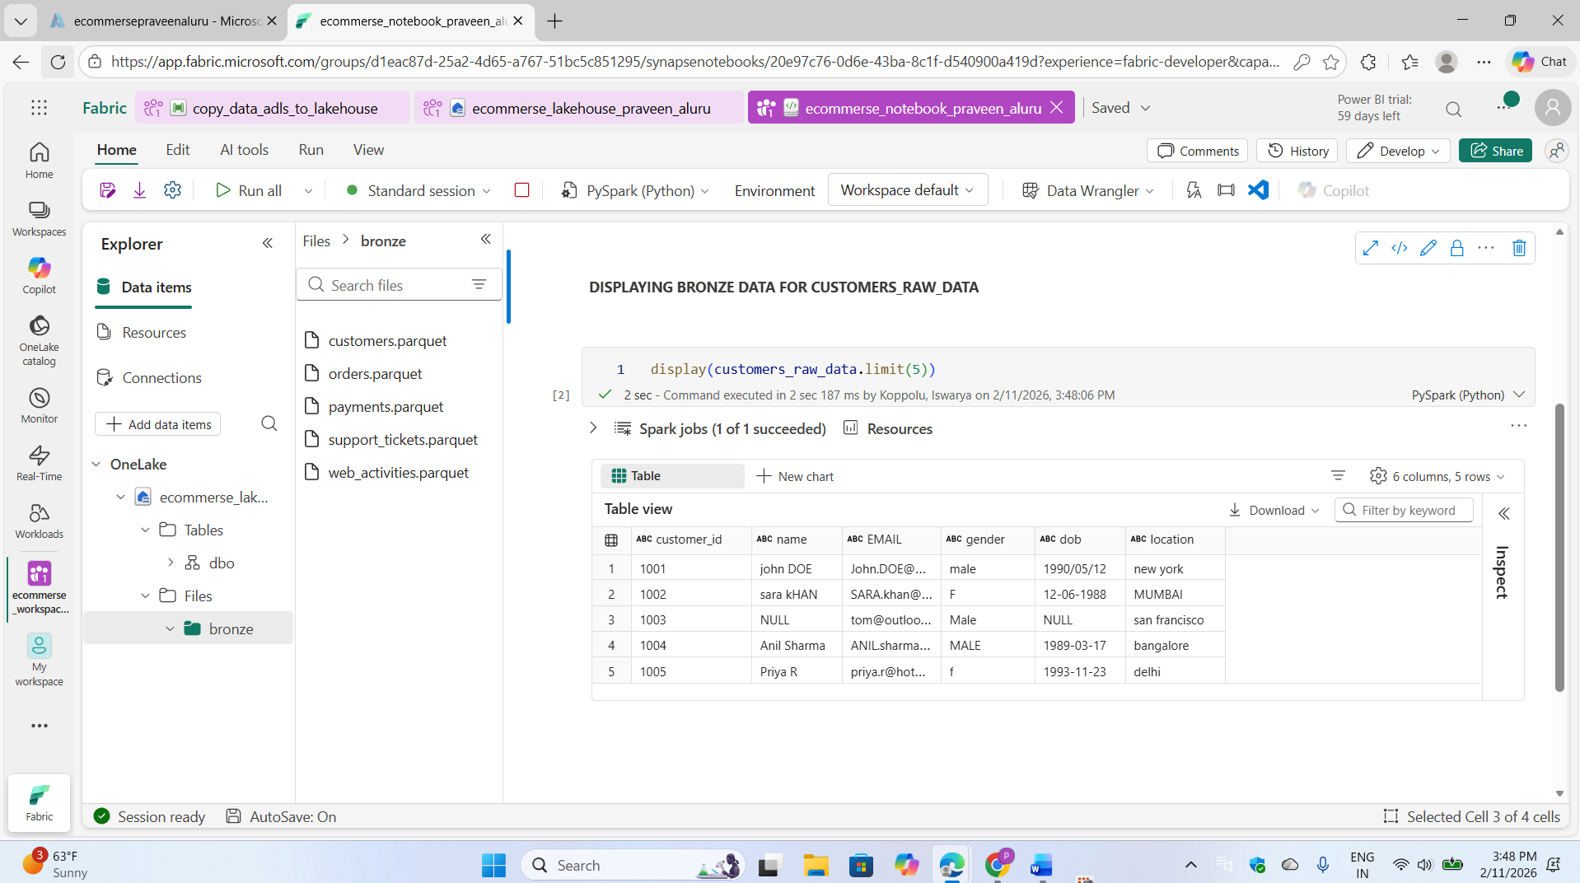

Similarly, Let's now display the top 5 records from the order file

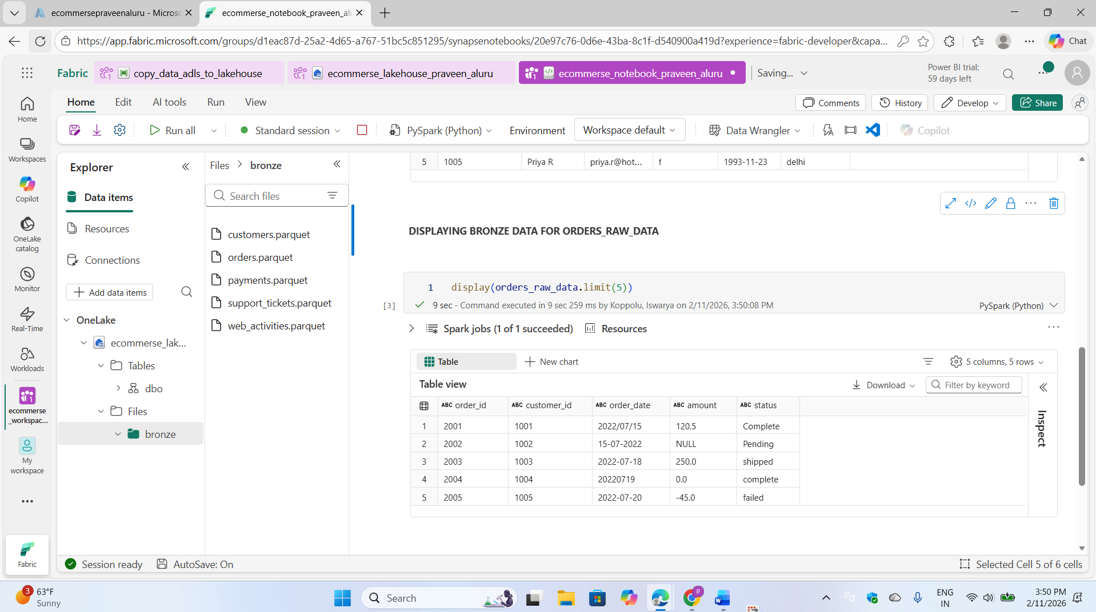

Let's now display the top 5 records from the payment file

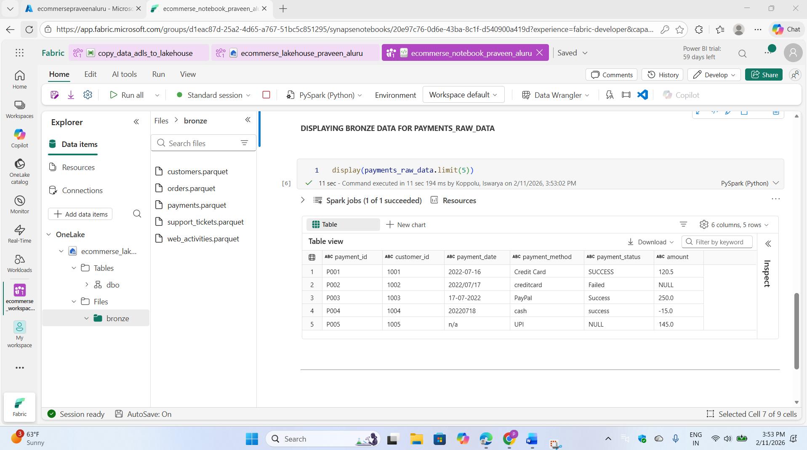

Let's now display the top 5 records from the support file

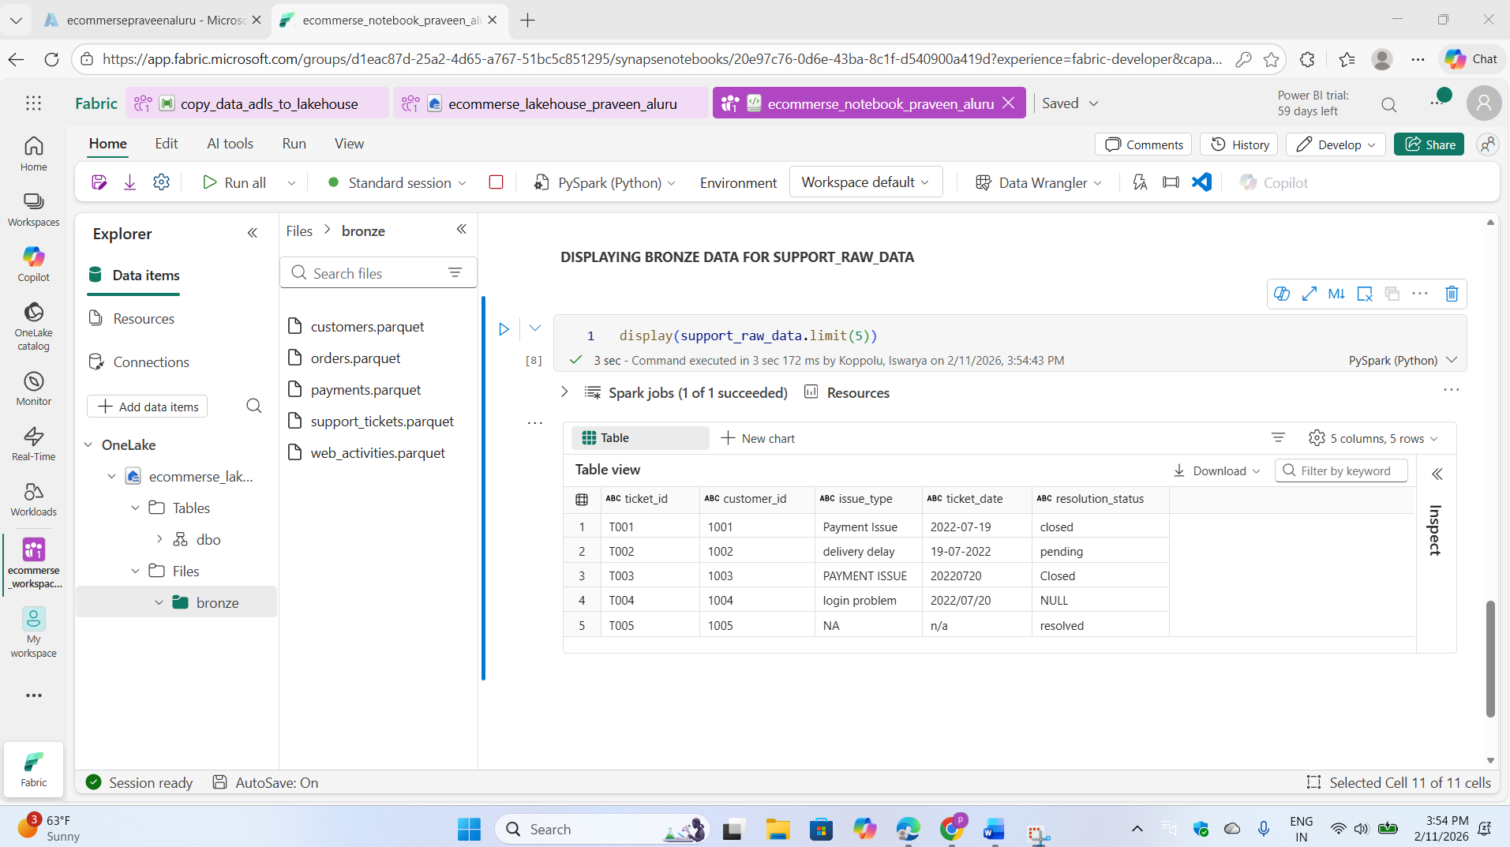

And display the top 5 records from the web_activity file

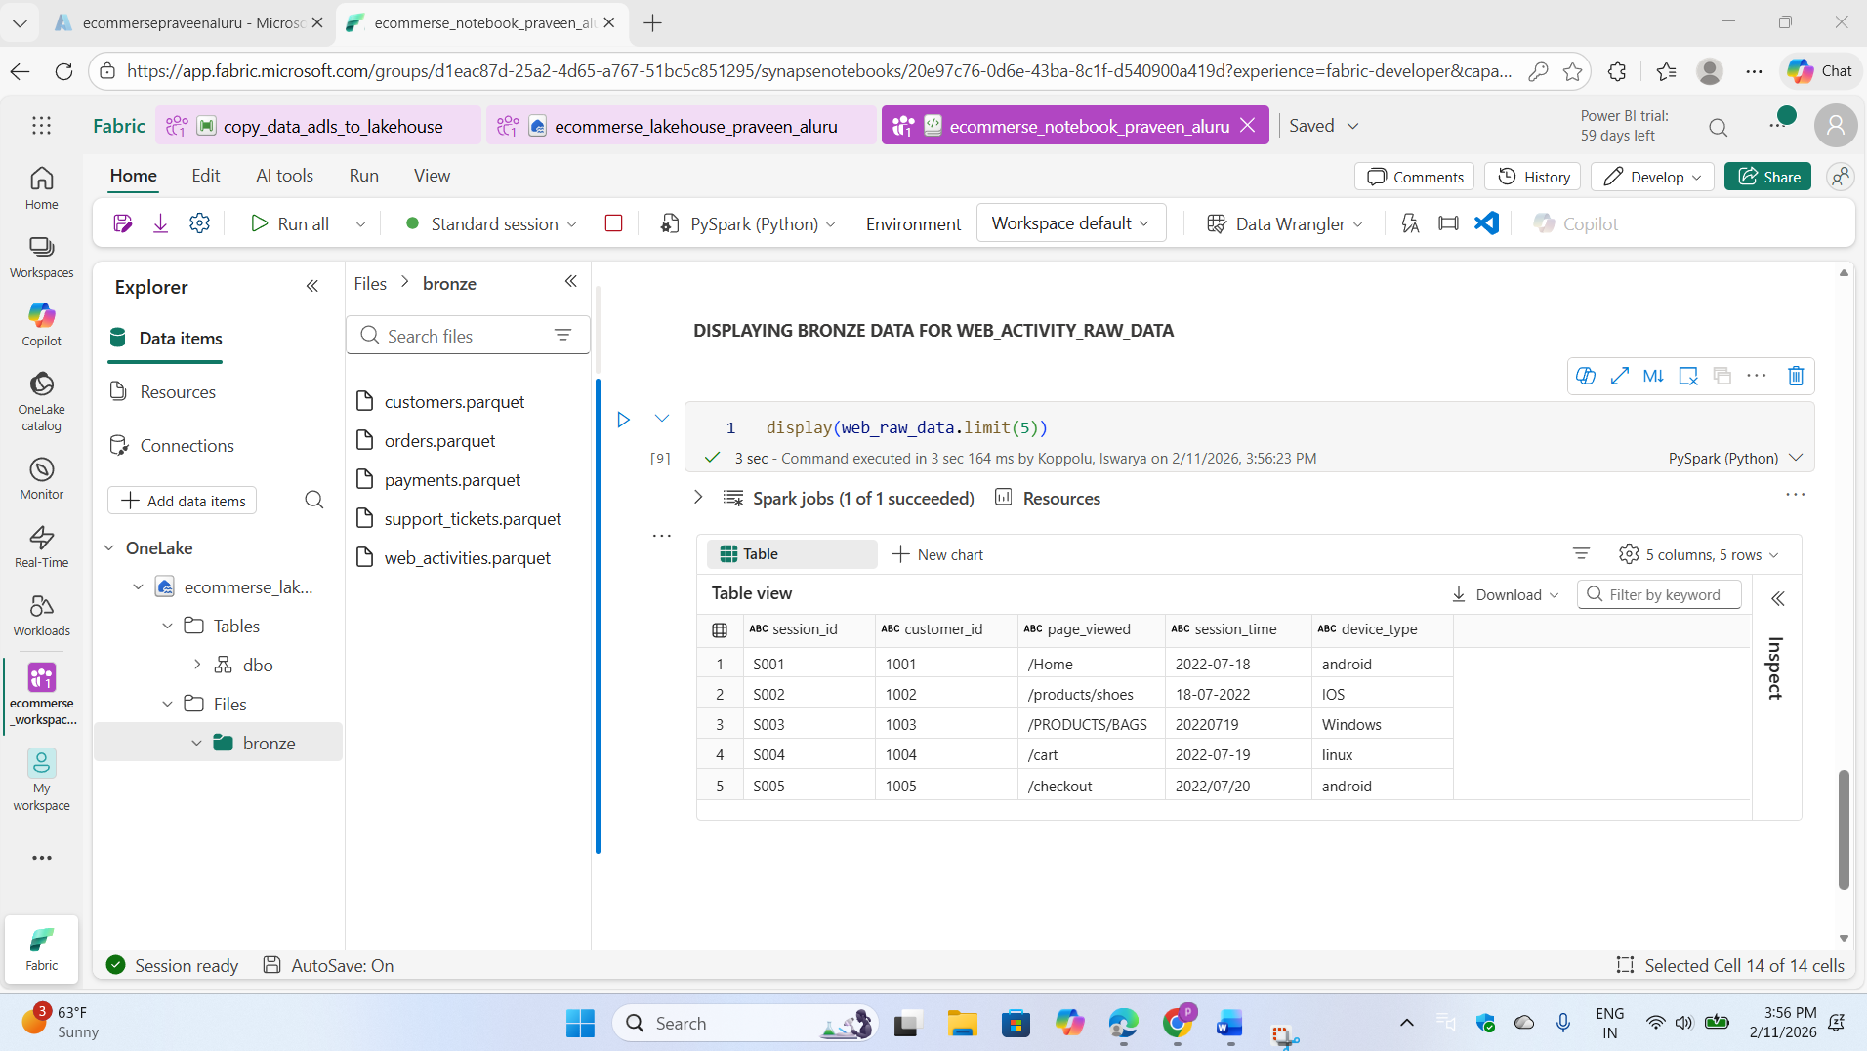

Now we are going to write it into managed tables as delta tables

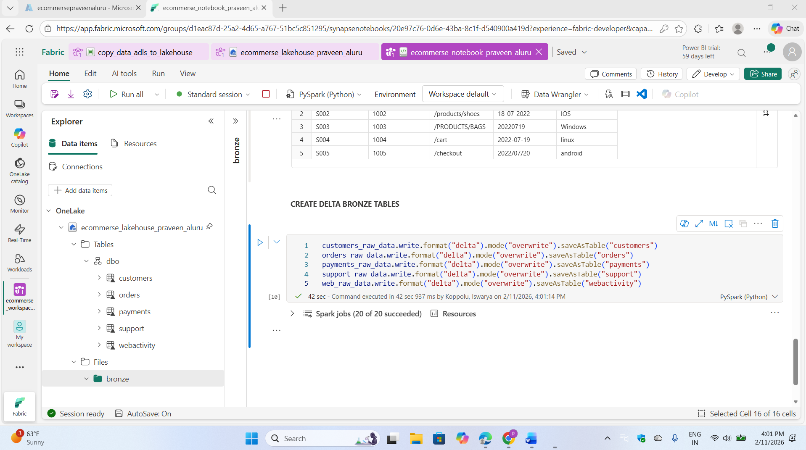

Let's display the actual customers data in its current state. Once we've reviewed it, we will perform the cleaning operations

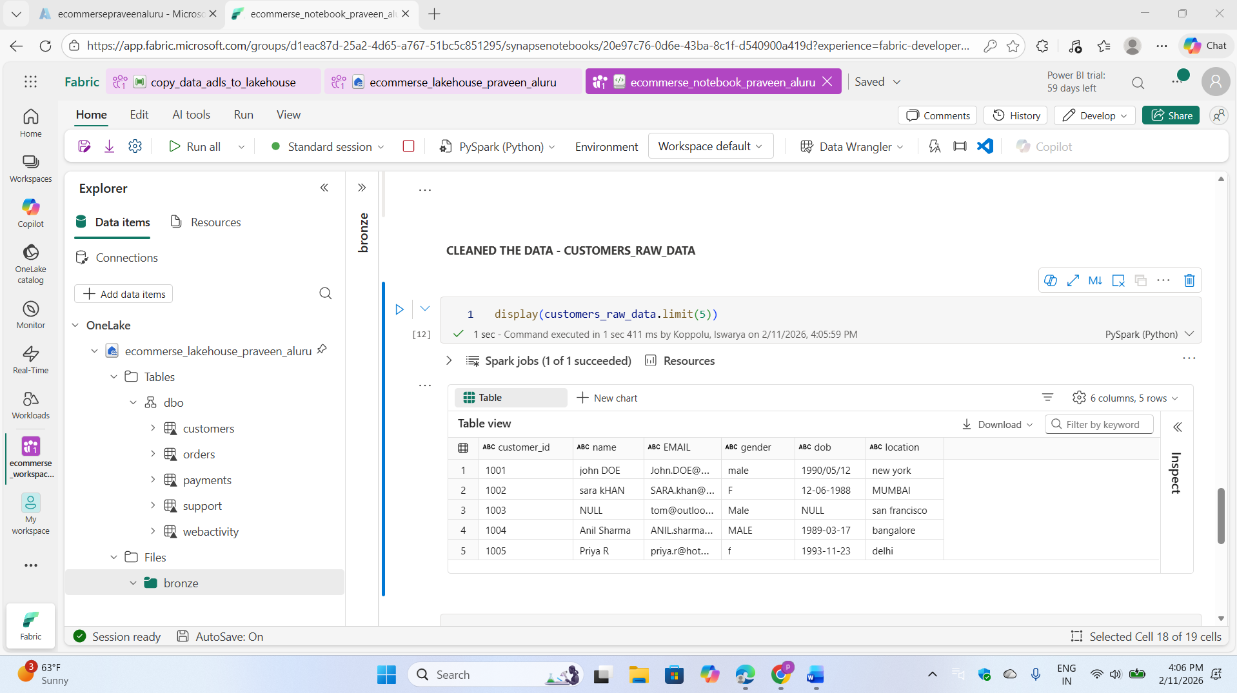

We will now clean the data using PySpark operations and import the necessary functions and types.

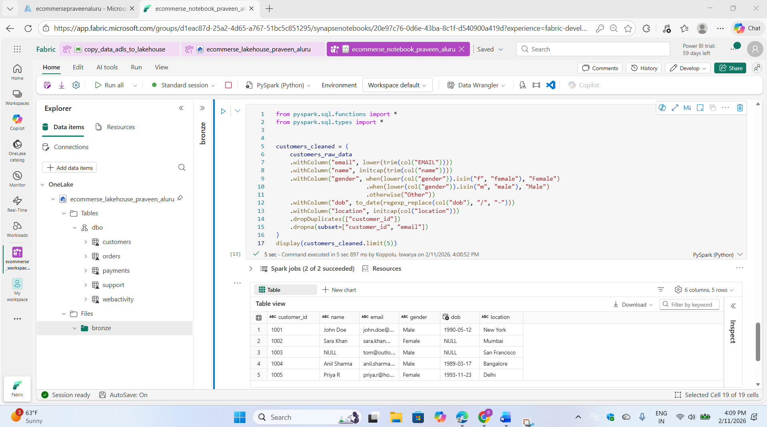

After cleaning the data, write it to a managed table in Delta format.

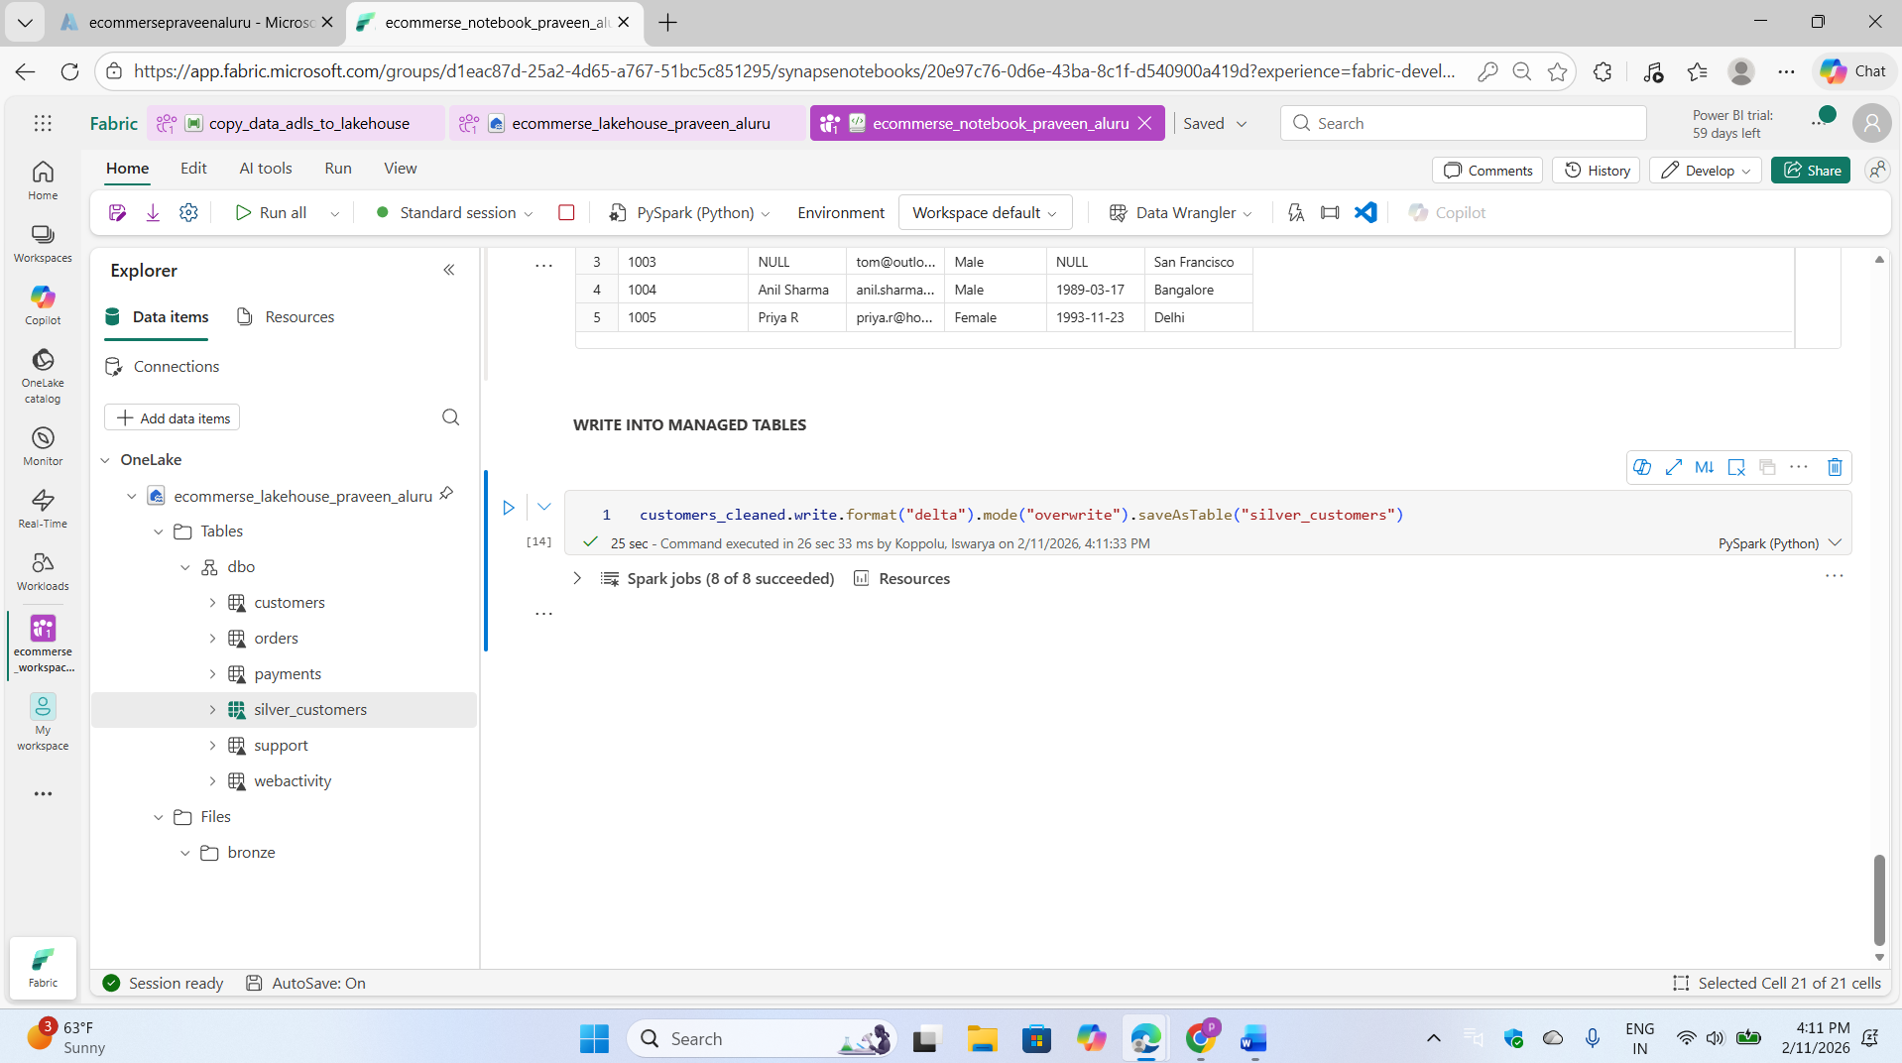

And same process for remaining cleaning files

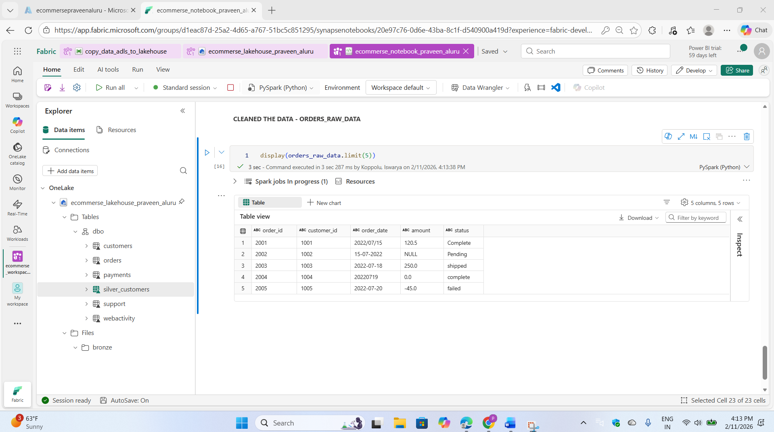

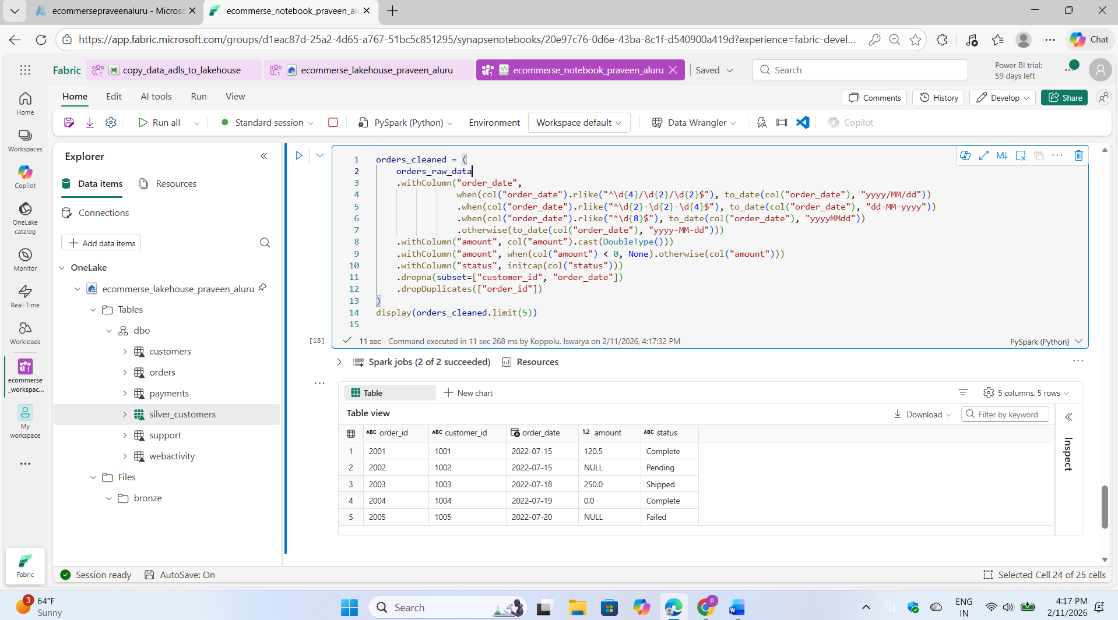

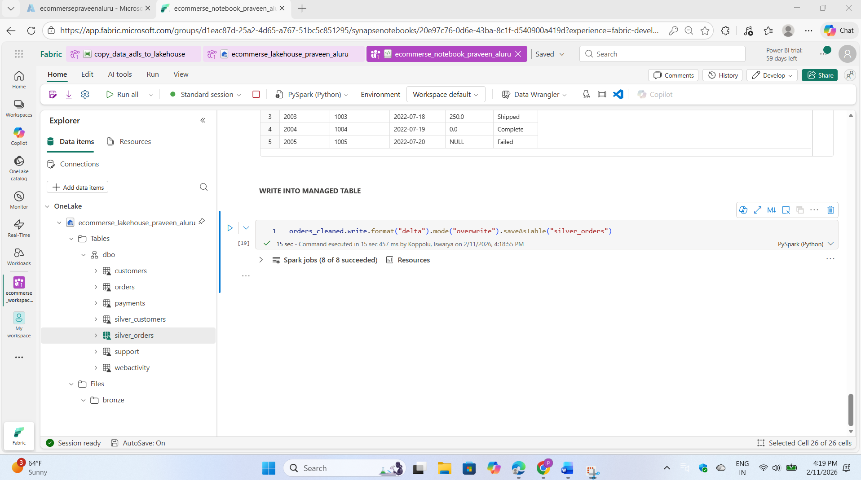

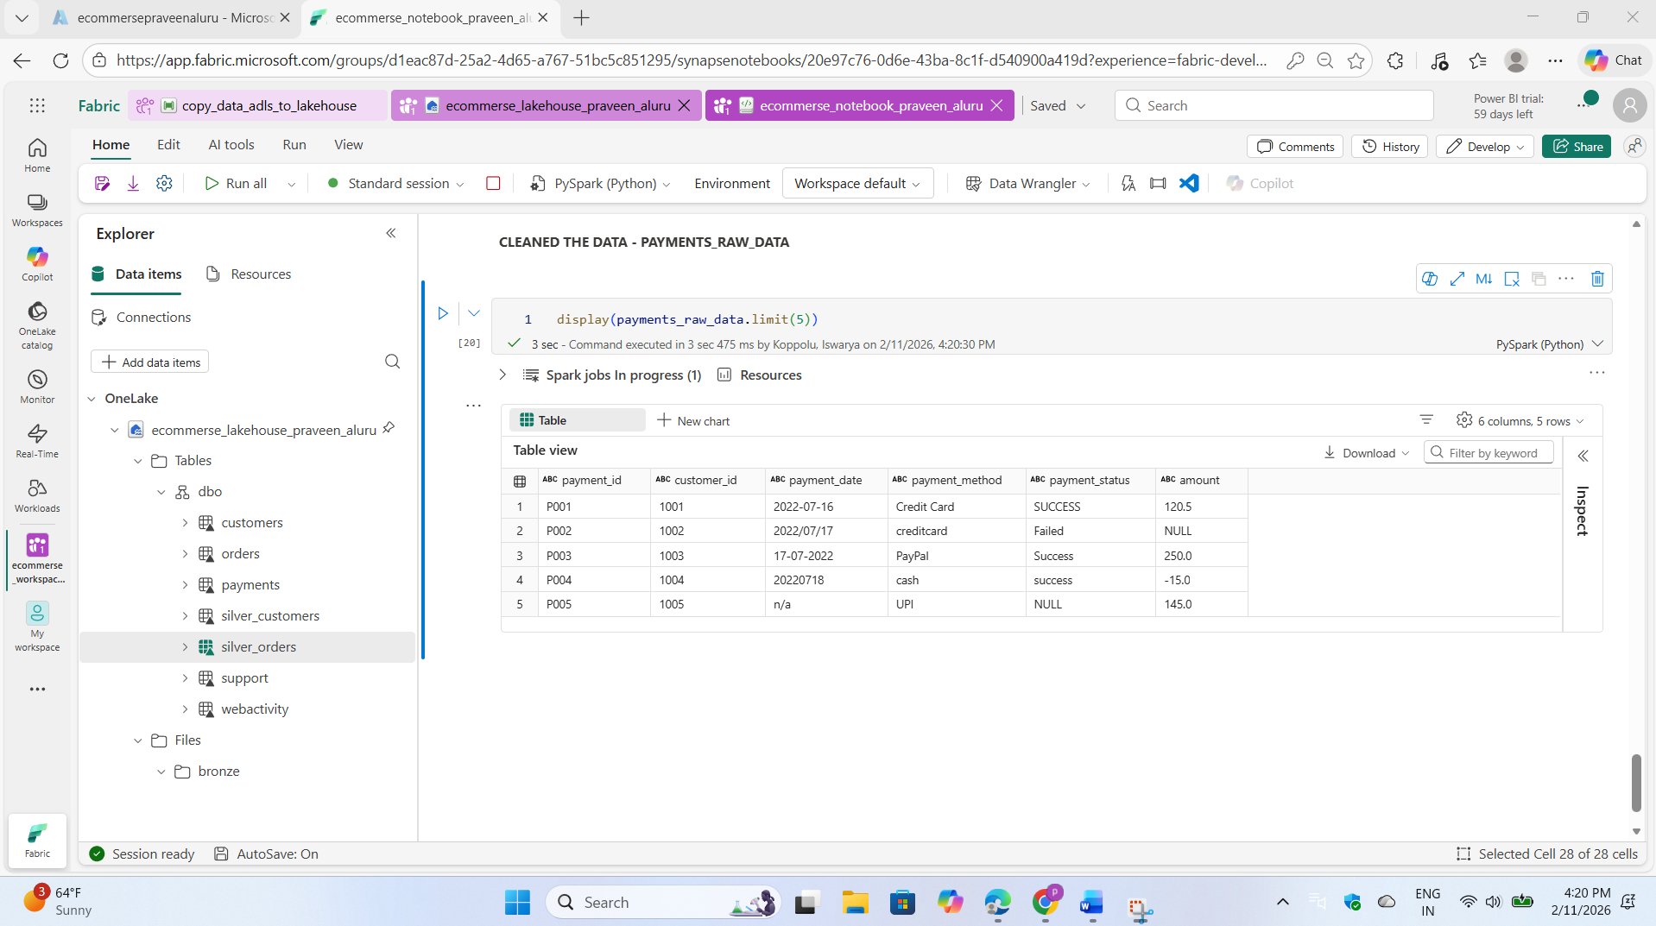

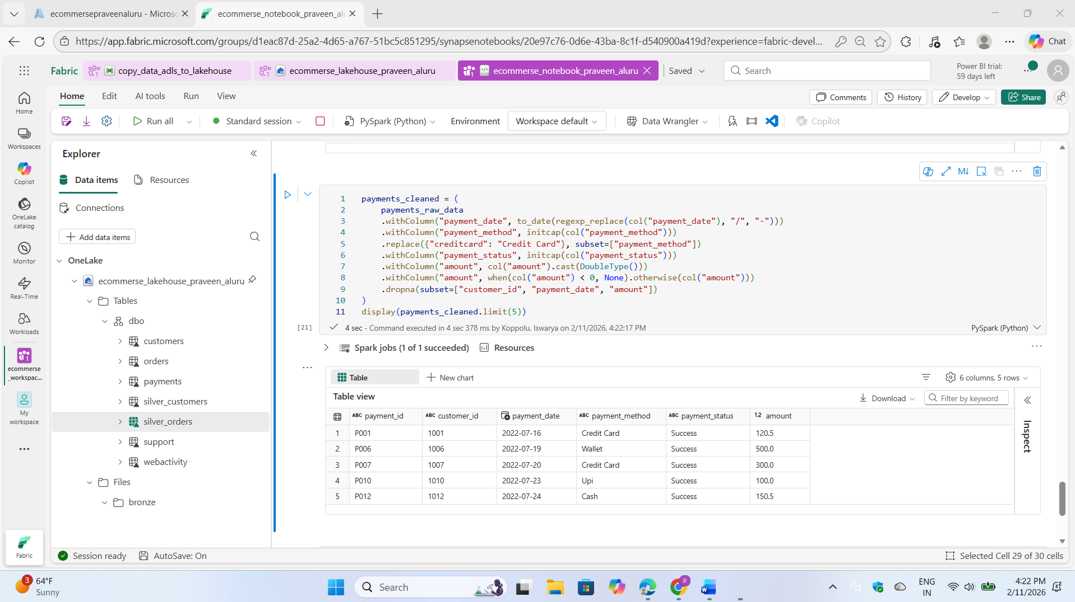

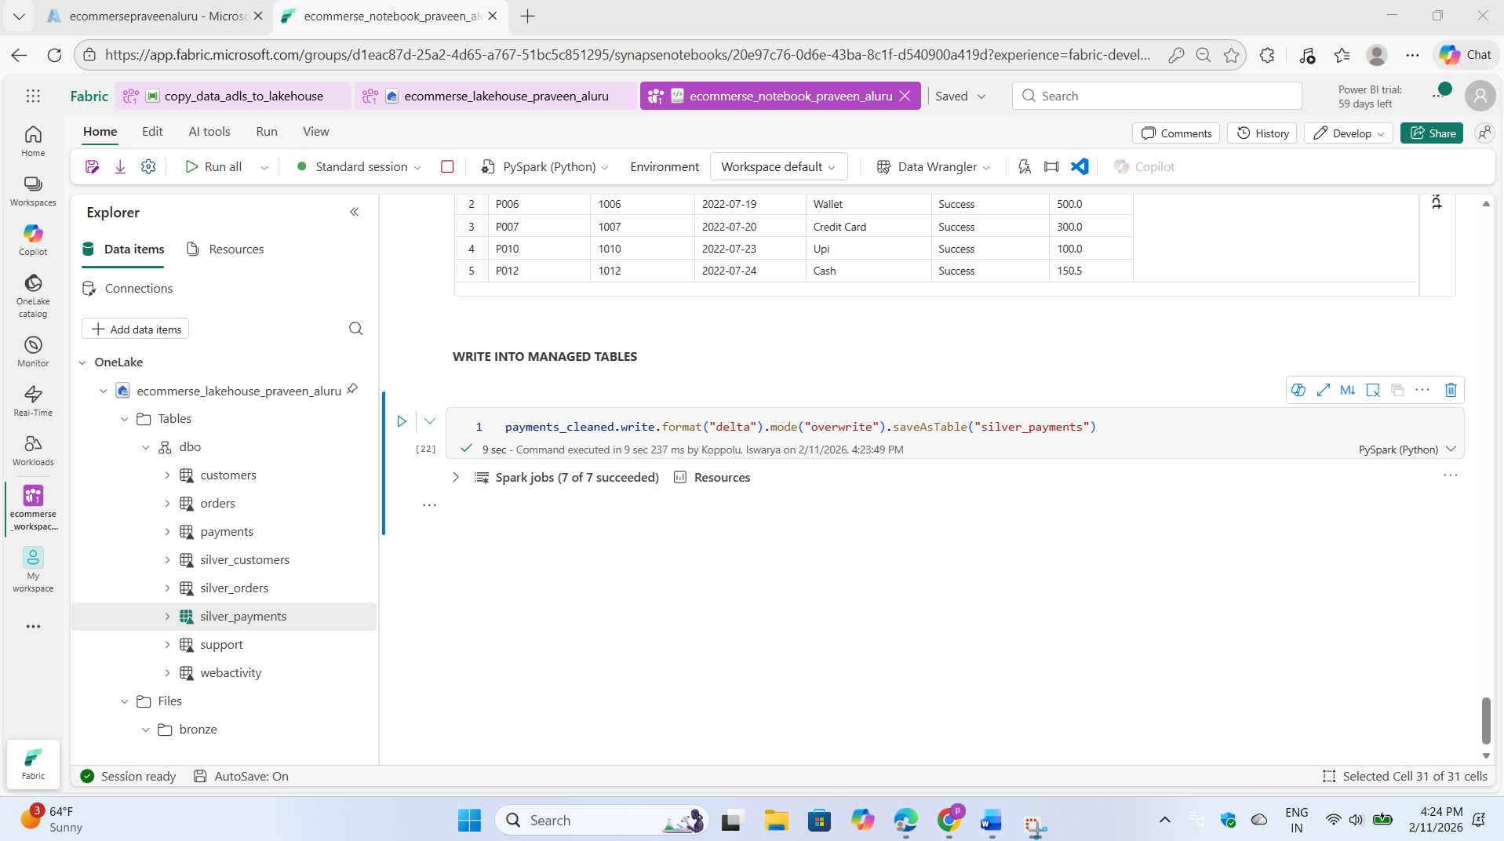

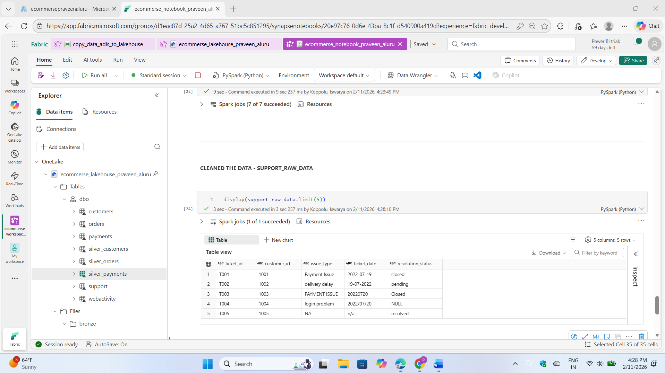

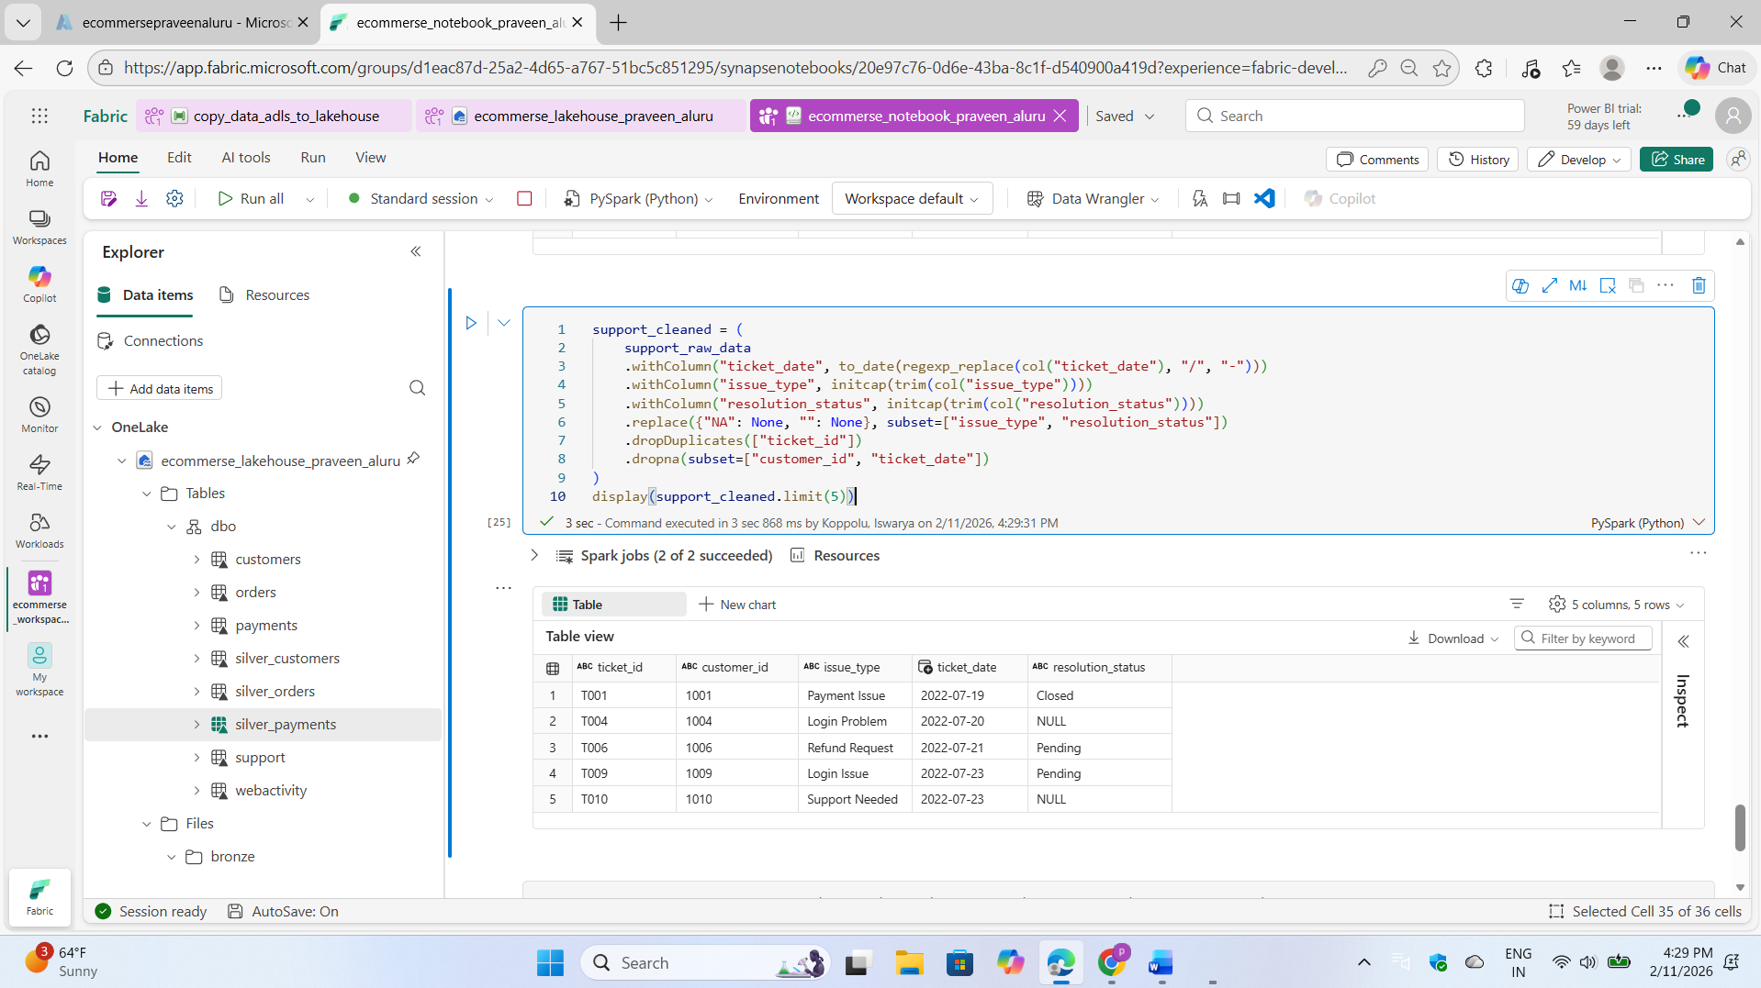

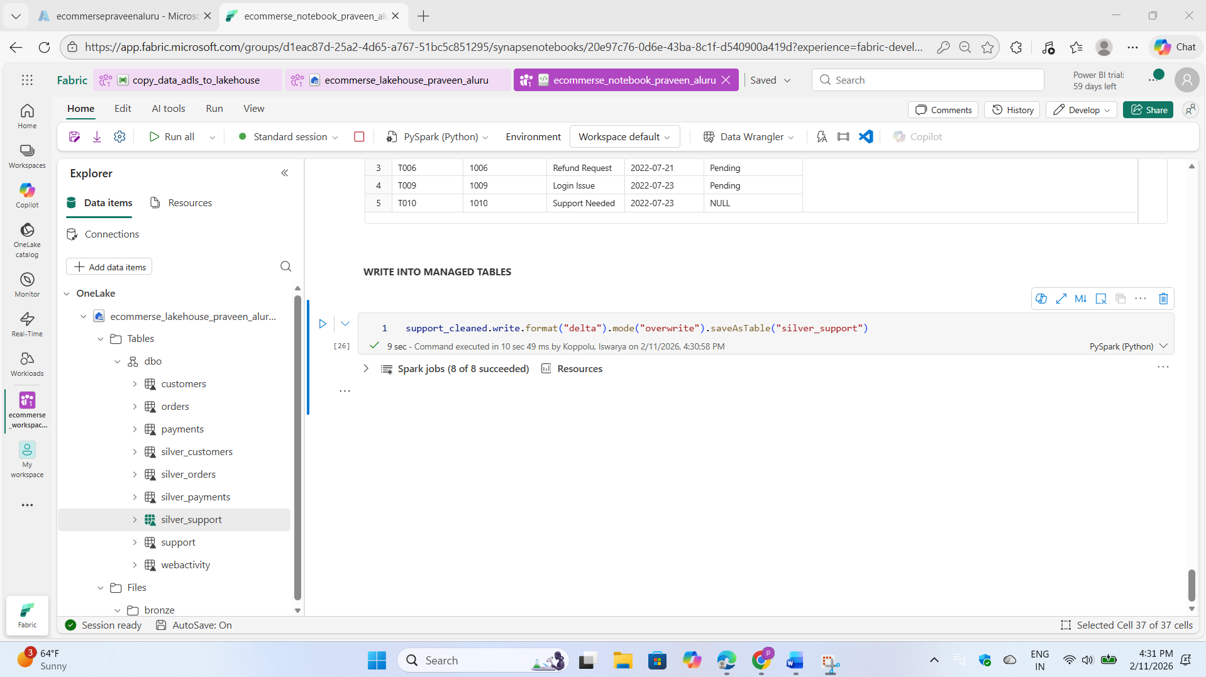

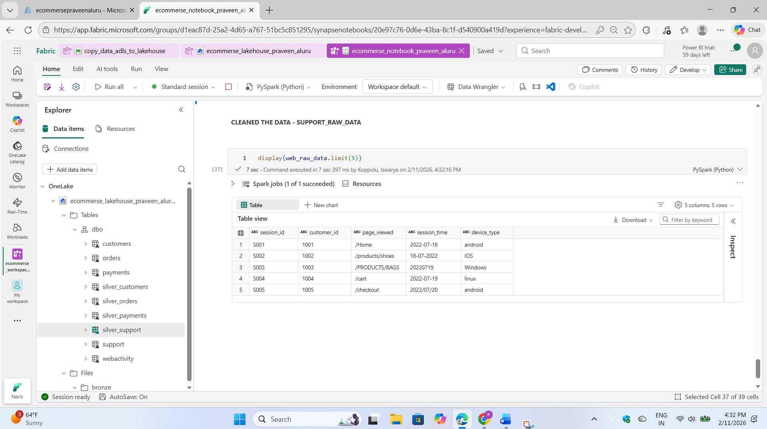

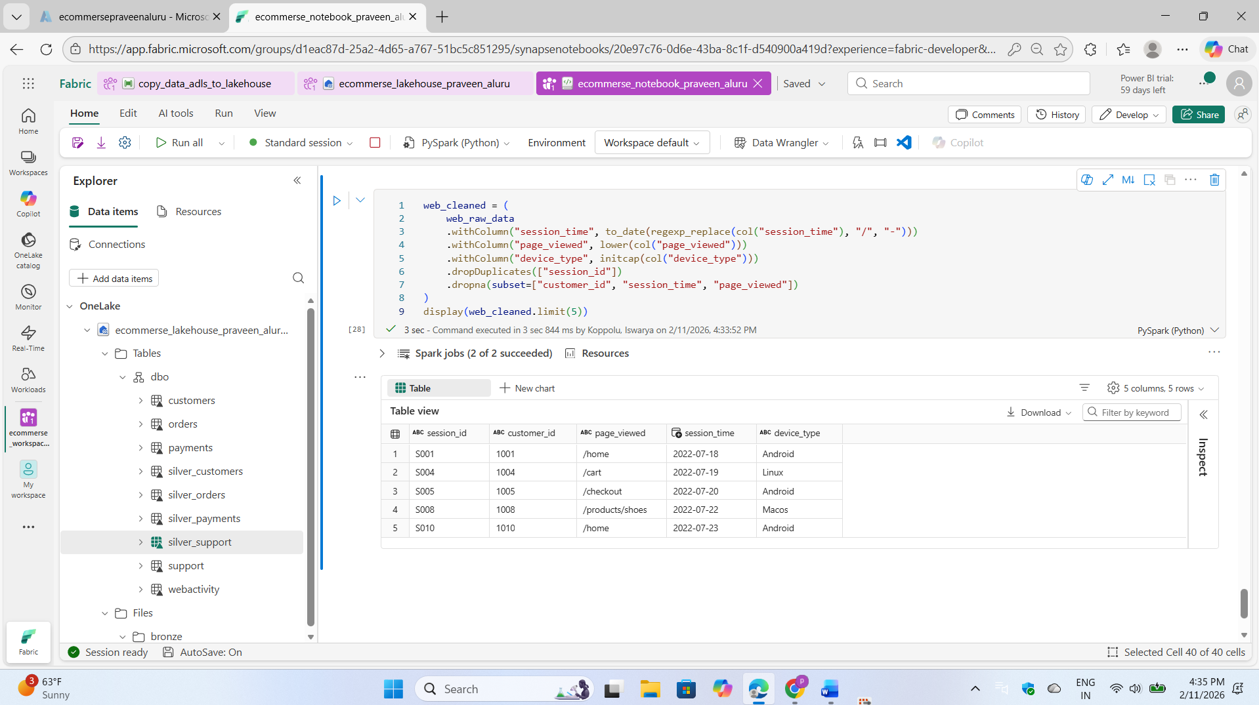

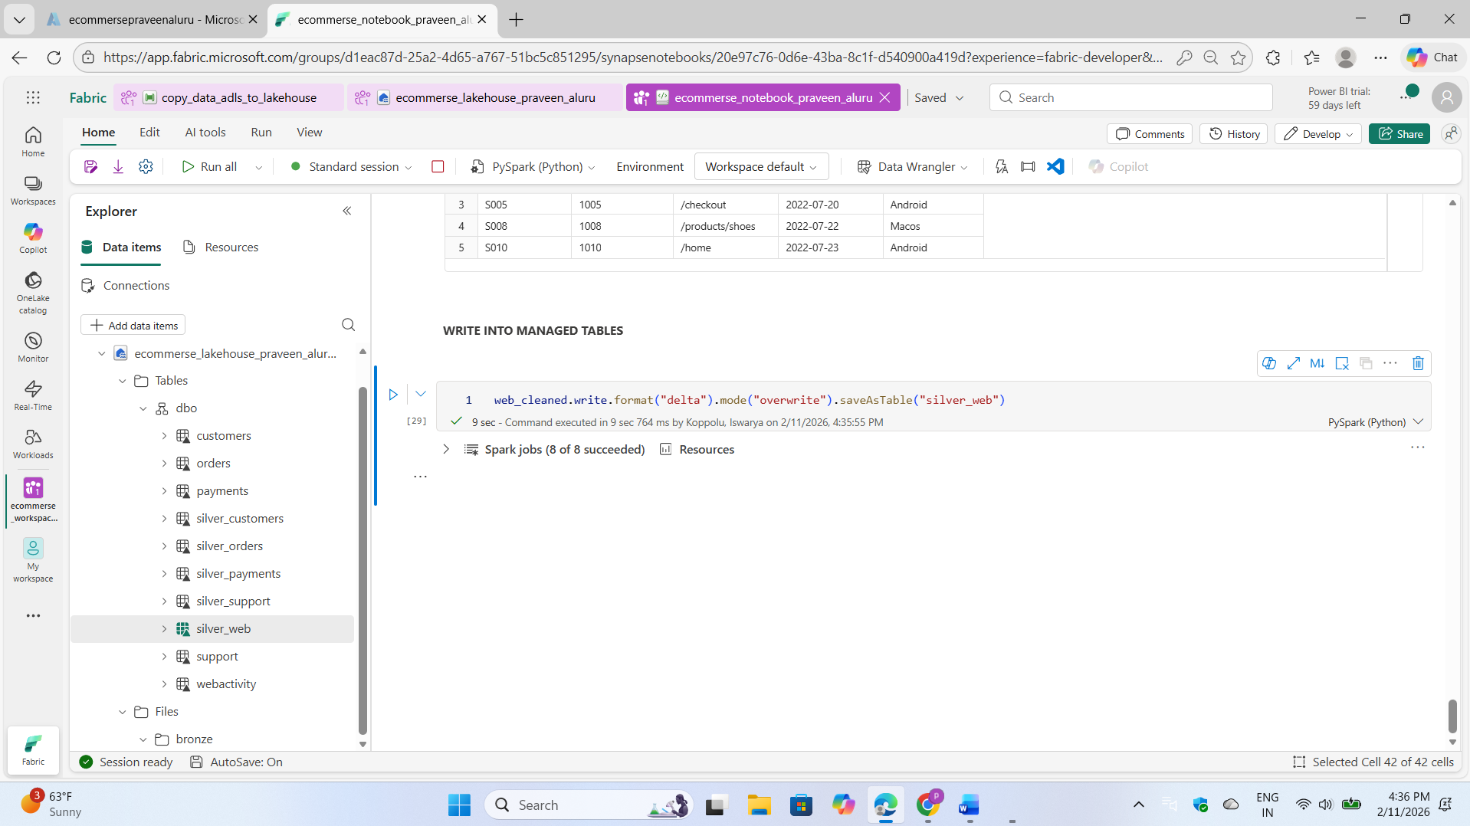

Step: 05

I created aggregated business metrics by building business-level tables and storing the results in the Gold Layer. SQL queries were executed to validate the accuracy and integrity of the data transformations.

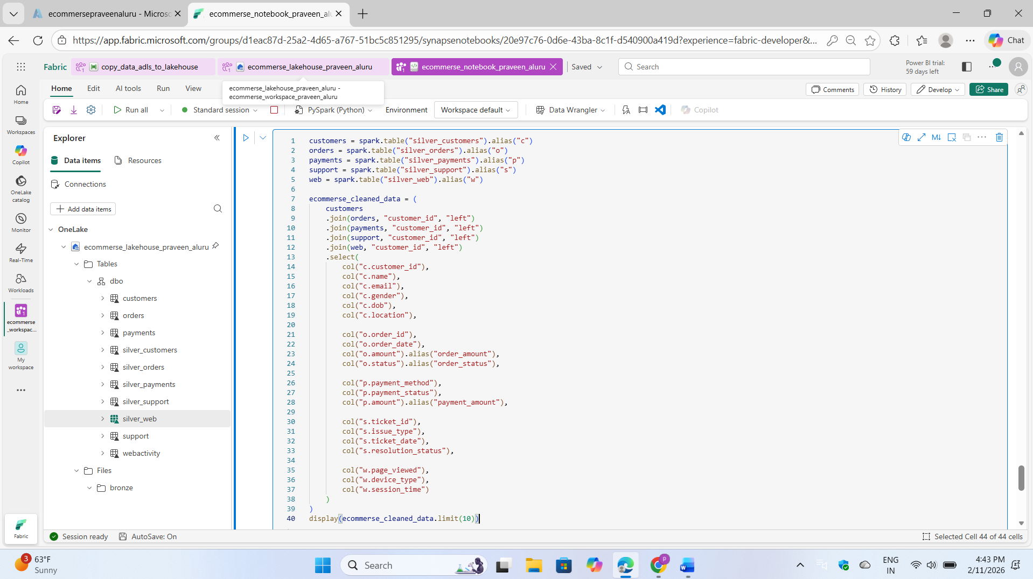

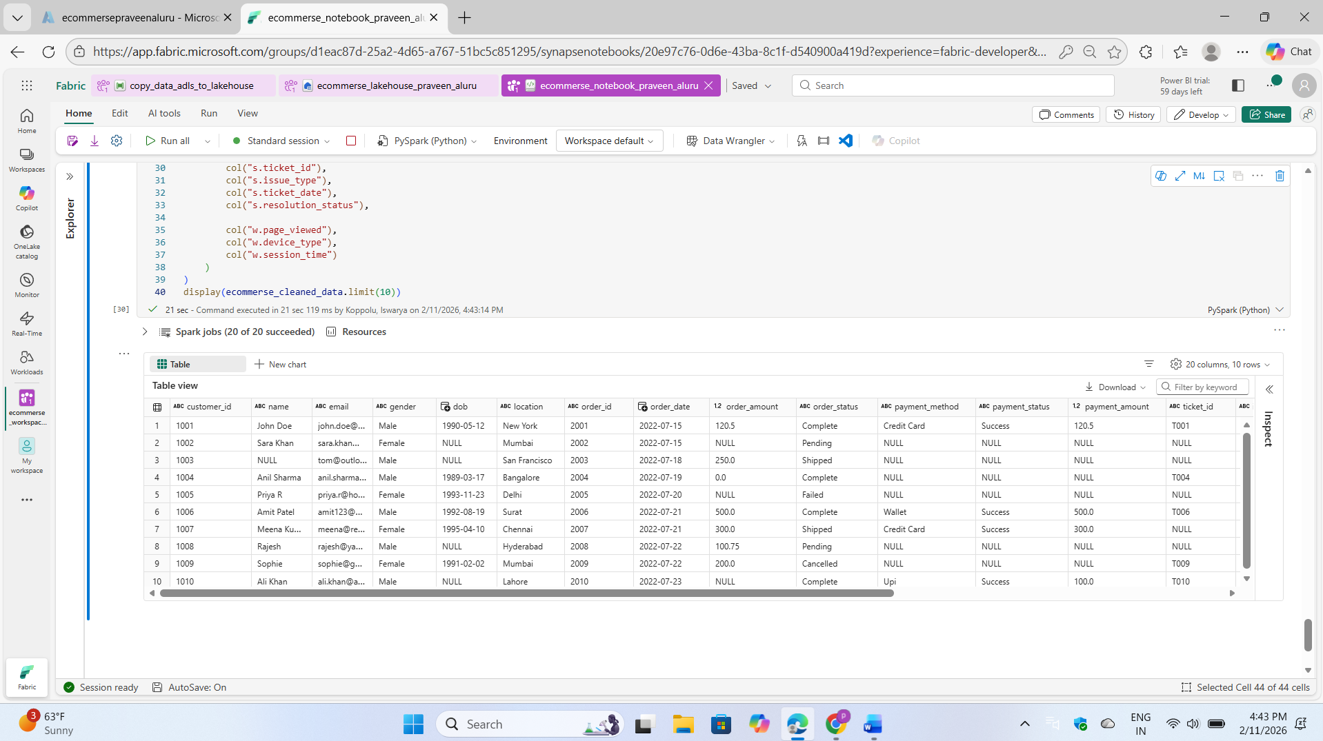

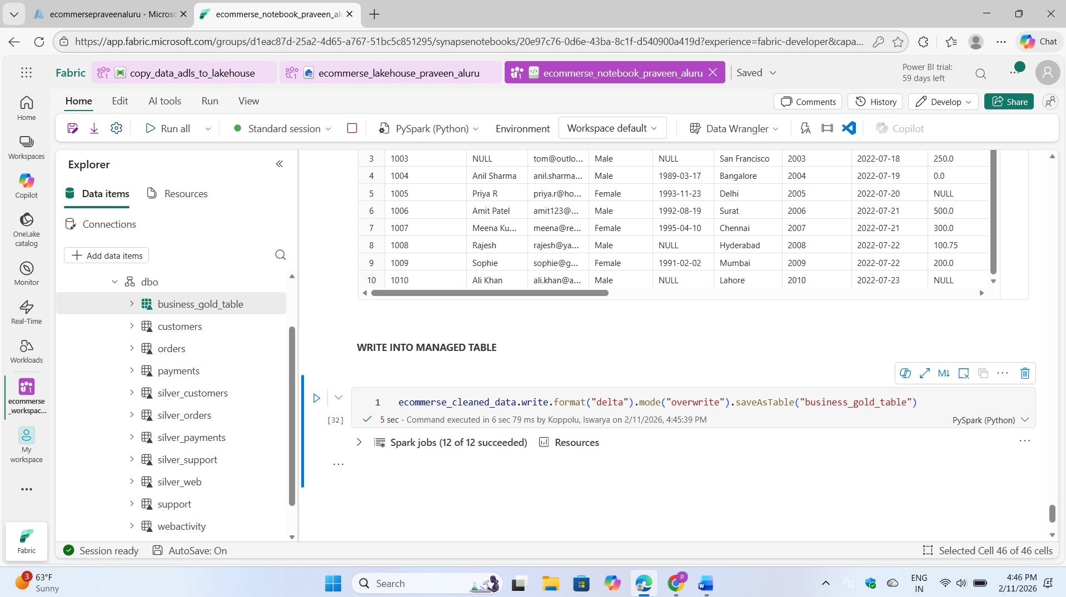

After the data transformation is complete and the results are written to the gold layer, we can run SQL queries to analyse the data.

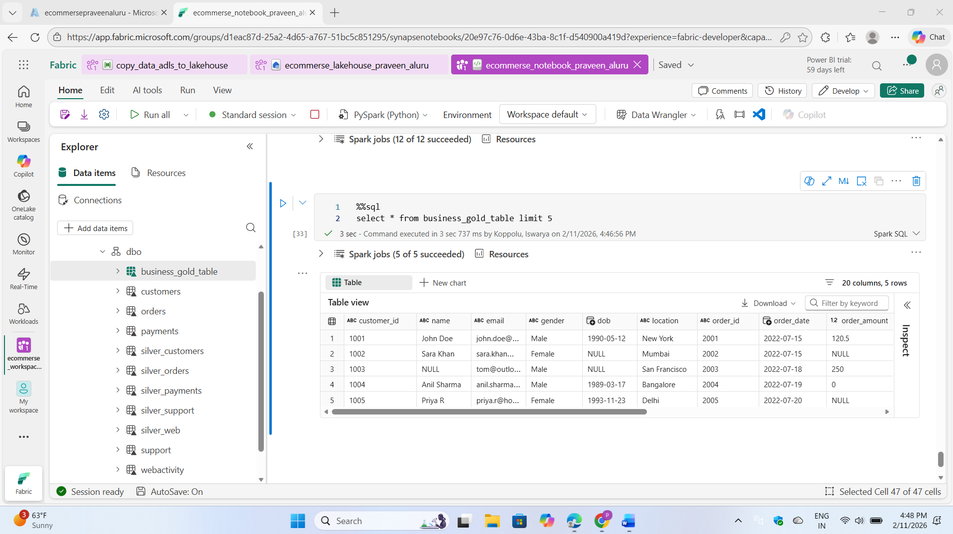

Data is ready for sematic models

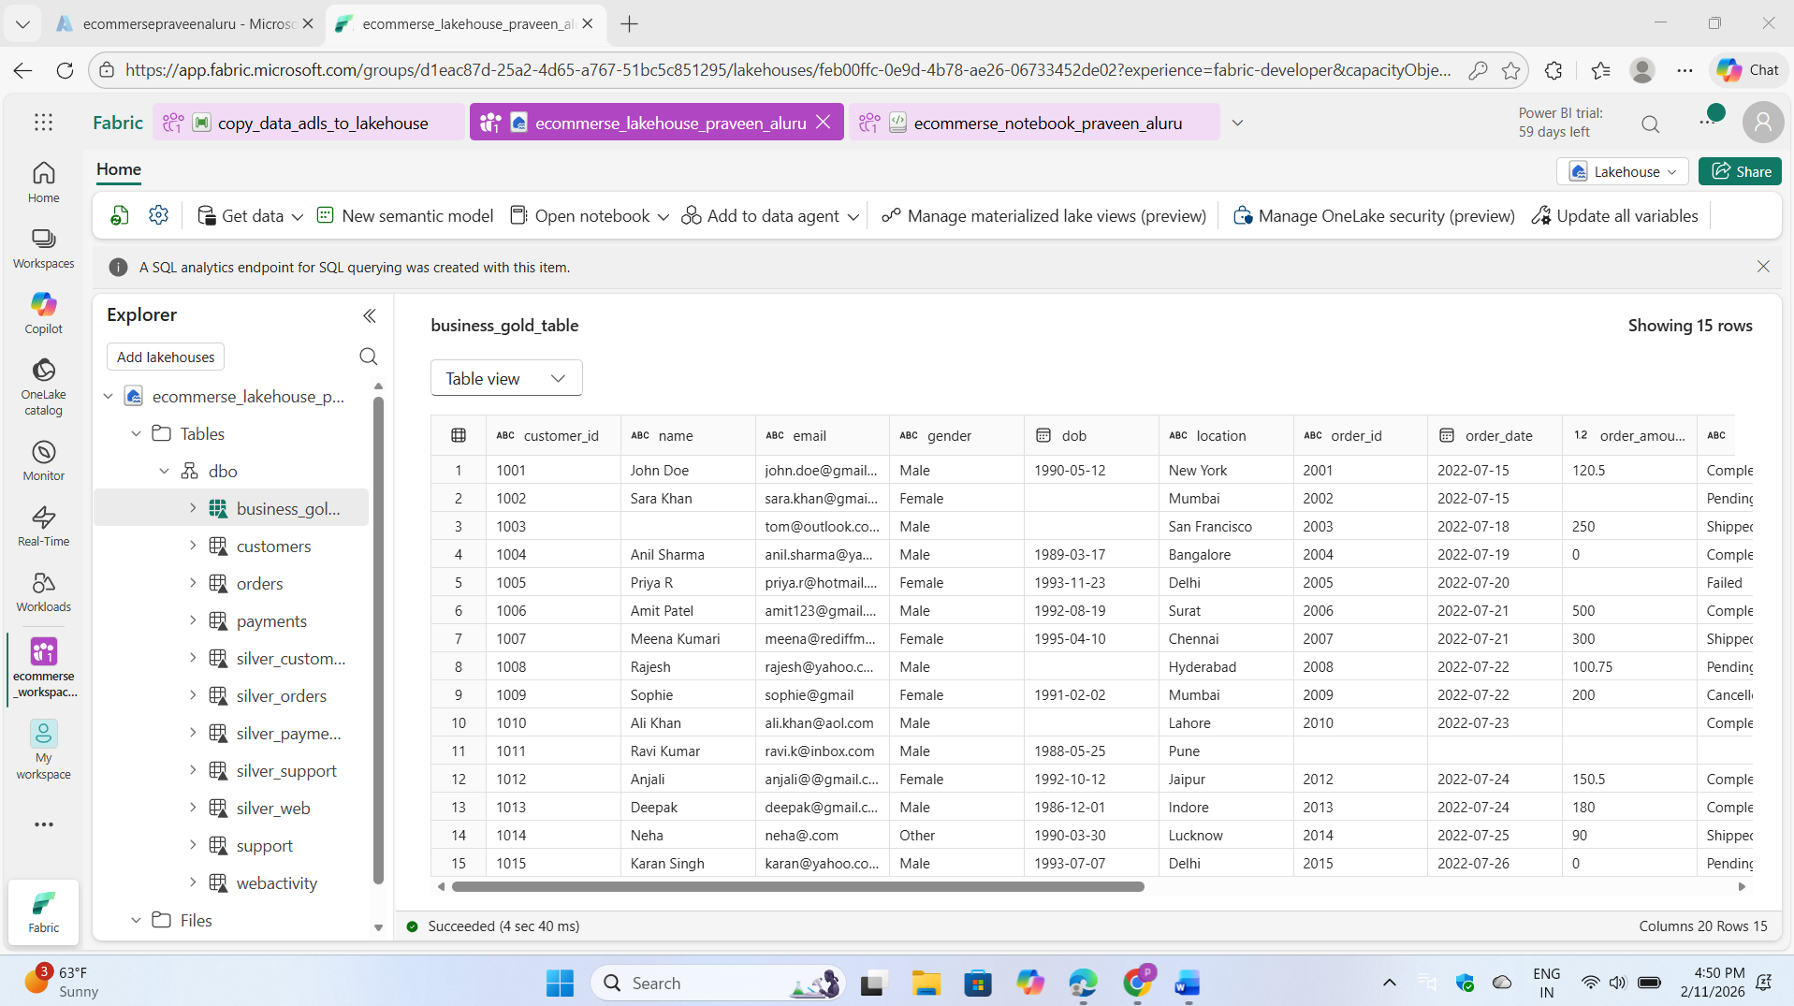

Step: 06

I created a semantic model by building relationships between tables, then designed comprehensive reports including a 360° customer view, location-based analysis focused on New York, and overall business performance metrics. This structured approach enabled integrated data analysis and meaningful insights across multiple business dimensions.

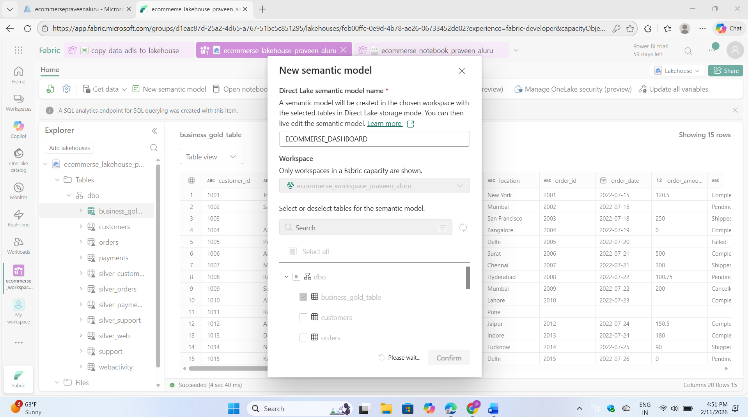

Created a report for 3600 eCommerce customers with location-level visuals for New York

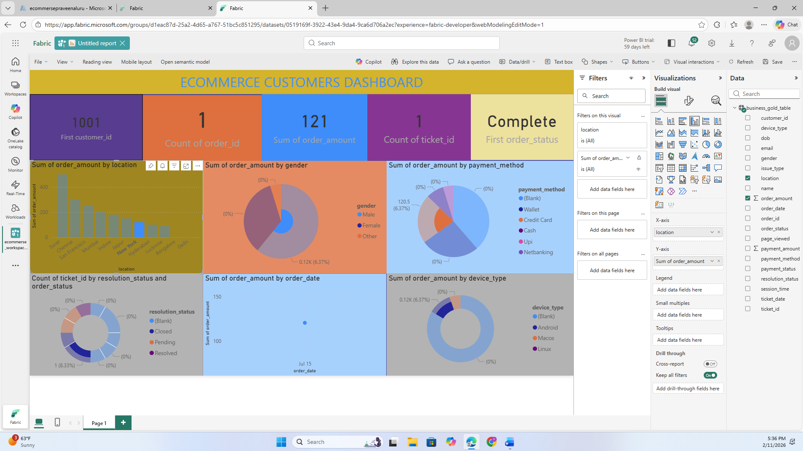

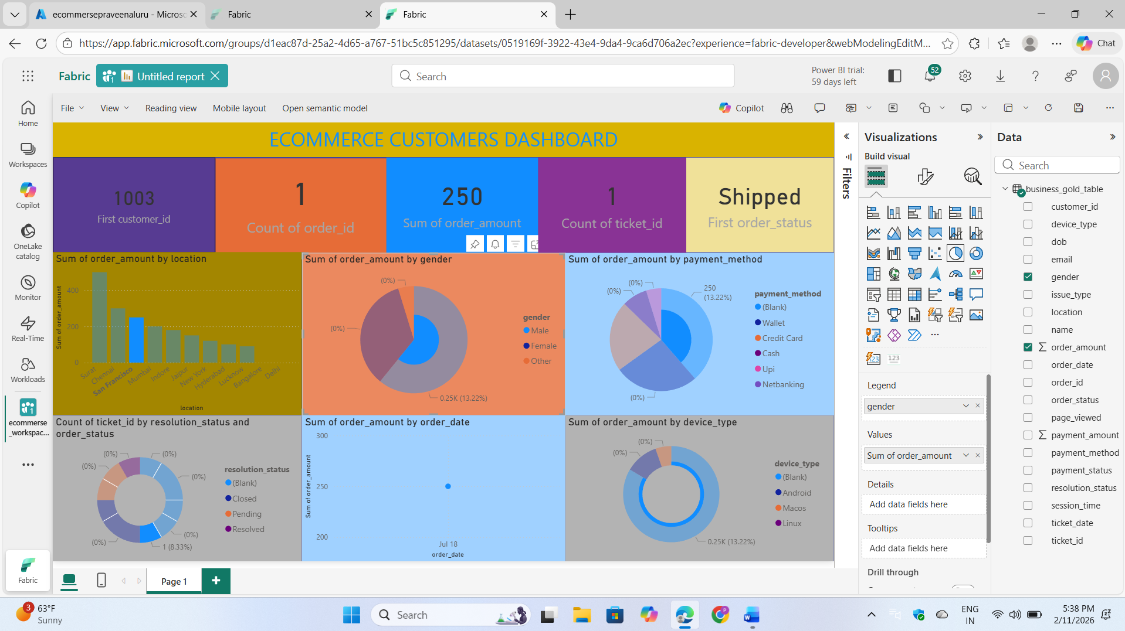

Here, Overall report

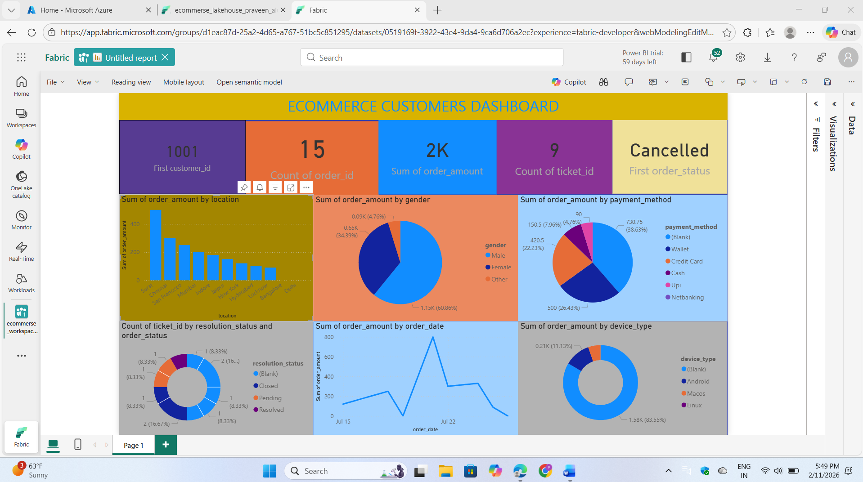

Step: 07

I performed a query operation on the full business table using SQL

